**THE MAHARAJA SAYAJIRAO UNIVERSITY OF BARODA**

**DEPARTMENT OF COMPUTER APPLICATIONS**

**FACULTY OF SCIENCE**



**An Internship Report**

**on**

**RPA Developer**

**for**

**N10 TechnoSoft**

**Submitted by**

**Vasu patel**

**PRN: 8021037985**

**in partial fulfillment for the award of the degree**

**of**

**Master of Information Technology**

**in the**

**Department of Computer Applications**

**April, 2023**

|  |  |
| --- | --- |
| **Internal Guide**  Ms. Mitali Hora  Assistant Professor | **External Guide**  Mr. Zeel Devendhra  RPA Trainer  N10 TechnoSoft |

**TABLE OF CONTENTS**

|  |  |
| --- | --- |
| ACKNOWLEDGEMENT………………………………………………………………………… | 3 |
| CERTIFICATE…………………………………………………………………………………. | 4 |
| CERTIFICATE BY ORGANIZATION………………………………………………………….. | 5 |
| Chapter 1. Introduction to Organization…………………………………………………. | Page No. |
| Chapter 2. List of Internship Assignments…………………………………………...…… | Page No. |
| Chapter 3. Software Modules and its Details…………………………………………….  3.1 Requirement Analysis of Modules Developed……………………………………….  3.2 System design of Modules……………………………………………………………  3.3 Database Design of Work done……………………………………………………….  3.4 Screenshots of the UI of the tasks performed………………………………………...  3.5 Test Reports of the Tasks Performed………………………………………………… | Page No. |
| Page No |
| Page No |
| Chapter 4. Experiences of Corporate culture and Working Atmosphere…………………. | Page No |
| REFERENCES………………………………………………………………………………… | Page No |

**ACKNOWLEDGEMENT**

Firstly, I would like to thank all the faculties of my college who supported me and helped me during the whole internship. I would also express my gratitude towards my mentor at the company who was of great help during the internship. We wish to express my sincere gratitude to the beloved Department head for giving me all the facilities for the internship. And I would also extend my special thanks to my internal guide Ms. Mitali Hora who guided me throughout the internship.

I am thankful for his aspiring guidance and valuable advice during the project work. Last but not least, I would like to thank my family and friends for giving valuable advice and moral support throughout the internship.

This journey has truly been a learning and understanding one which has not only broadened our horizons but also made us gain new perspectives. We perceive this opportunity as a big milestone in our career development. We will strive to use gained skills and knowledge in the best possible way, and we will continue to work on our improvement, in order to attain desired career objectives.

**CERTIFICATE**

This is to certify that Mr. Vasu Patel student of **Master of Information Technology** (PRN 8021037985) in the Department of Computer Applications, Faculty of Science, The Maharaja Sayajirao University of Baroda, Vadodara, has successfully completed the Internship prescribed for the fourth semester of the programmed during the period from 12 December 2022 to 28 April 2023 towards the partial fulfillment for the degree of Master of Information Technology.

Date: 21/04/2023

Name & Signature of the Guide Head, Department of Computer

Applications

**CERTIFICATE BY ORGANIZATION**

1. **Introduction**

**1.1 About Organizatio**

N10 Technosoft is a dynamic startup that specializes in RPA, web development, and android development. Established in April, 2022, N10 Technosoft has already made significant strides in these areas, having worked with 8 clients and achieved notable success in a relatively short period of time.

At N10 Technosoft, we are driven by our passion for innovation and our commitment to delivering exceptional results for our clients. Our team comprises of highly skilled professionals who bring a wealth of experience and expertise to every project we undertake in the areas of RPA, web development, and android development. We work closely with our clients to understand their unique requirements and develop tailor-made solutions that address their specific needs.

At N10 Technosoft, we are constantly exploring new technologies and innovative approaches to stay ahead of the curve in our industry. Our focus on agility and adaptability has allowed us to quickly pivot and adjust to changing market conditions in the areas of RPA, web development, and android development, ensuring that we remain competitive and relevant.

We are excited about the potential of N10 Technosoft and are committed to realizing our vision of becoming a leading player in the RPA, web development, and android development markets. With a talented team, a strong track record of success in these areas, and a commitment to excellence, we are confident that N10 Technosoft is well-positioned for future growth and success.

**1.2 Service Offered by organization**

**1.2.1 Services**

There are several services which are been provided by our organization

from which some are listed below:

* Business Process Automation

We help you identify routine activities and automate them using technology to improve efficiency & reduce costs. Identify routine activities and automate them using technology to improve efficiency and reduce costs. At N10 Technosoft, we use Robotic Process Automation (RPA) to solve for the business as a whole. RPA refers to a technology that builds, deploys, and manages robotic software that imitates human actions such as understanding what's on a screen, identifying and extracting data, and carrying out other similar, repetitive, defined actions.

* Process Optimization Consulting

Improve processes within your business to boost the speed and effectiveness of every workflow. Process Optimization Consulting is a service offered by consulting firms to help organizations improve their business processes in order to increase efficiency, reduce costs, and improve overall performance. The process optimization consultant works closely with the client organization to identify areas where processes can be streamlined, eliminate unnecessary steps, automate certain tasks, and improve the flow of information.

Process Optimization Consulting is a service offered by consulting firms to help organizations improve their business processes in order to increase efficiency, reduce costs, and improve overall performance. The process optimization consultant works closely with the client organization to identify areas where processes can be streamlined, eliminate unnecessary steps, automate certain tasks, and improve the flow of information.

* Mobile Applications

We help you identify routine activities and automate them using technology to improve efficiency & reduce costs. A mobile application, commonly known as a mobile app, is a software application designed to run on mobile devices such as smartphones, tablets, or smartwatches. Mobile apps are typically available for download through app stores such as Apple App Store and Google Play Store.

Mobile apps are designed to provide a wide range of services, such as gaming, entertainment, social media, productivity, and utility. These apps can be used to perform various tasks, such as booking a flight, ordering food, paying bills, tracking fitness goals, or controlling home automation systems.

Mobile apps are developed using various programming languages, including Java, Swift, Objective-C, and Kotlin. They can be native apps, which are developed specifically for a particular operating system (such as iOS or Android), or hybrid apps, which are developed using web technologies (such as HTML, CSS, and JavaScript) and can run on multiple platforms.

* Web Development

Web development is the process of creating websites and web applications for the internet or intranet. Web development involves several tasks, including web design, content creation, client-side scripting, server-side scripting, and network security configuration.

Web development can be divided into two main categories: front-end development and back-end development. Front-end development involves creating the user interface, the visual aspects of a website, and how it interacts with the user. This includes HTML, CSS, and JavaScript, which are used to create the layout, style, and functionality of the website.

Back-end development, on the other hand, involves creating the server-side of the website, the part that the user doesn't see. This includes server-side scripting languages like PHP, Ruby, and Python, which are used to develop applications, manage databases, and handle server-side logic.

**1.3 Clients of Organization**

* BRIDGESTONE
* OAKDALE MORTGAGE
* E-CONTRACTORS
* ACE ACEDMEY
* RELY SERVICES

**1.4 Tools and Technologies**

* RPA
  + Automation anywhere

Automation Anywhere is a software company that provides a platform for Robotic Process Automation (RPA). RPA is a technology that allows businesses to automate repetitive tasks by using software robots or "bots" to perform them. These tasks can include data entry, invoice processing, customer service, and other back-office functions.

The Automation Anywhere platform provides a range of tools and services for creating, managing, and running bots. These tools include a drag-and-drop interface for creating workflows, a bot creation tool for building custom bots, and a dashboard for monitoring and managing bot performance.

One of the key benefits of Automation Anywhere is that it can integrate with a wide range of other applications and systems, including ERP and CRM systems, databases, and web applications. This allows businesses to automate end-to-end processes across multiple systems, reducing errors and improving efficiency

* + UiPath

UiPath is a software company that provides a platform for Robotic Process Automation (RPA). RPA is a technology that enables businesses to automate repetitive and manual tasks by using software robots, or "bots," to perform them. UiPath's platform provides a range of tools and services for creating, managing, and running bots.

One of the key features of UiPath is its drag-and-drop interface, which enables users to create workflows without needing extensive programming knowledge. The platform also offers a wide range of pre-built activities and templates that can be customized and combined to create more complex workflows.

UiPath can integrate with a wide range of other applications and systems, including ERP and CRM systems, databases, and web applications. This allows businesses to automate end-to-end processes across multiple systems, reducing errors and improving efficiency.

* Android Studio
  + Java

Java is a popular programming language used for building a wide range of applications, from mobile apps to web-based enterprise systems. It was first introduced in 1995 by Sun Microsystems, which was later acquired by Oracle Corporation.

One of the key features of Java is its platform independence, which means that Java programs can run on any platform that has a Java Virtual Machine (JVM). This makes Java a popular choice for developing cross-platform applications. Java also has a large and active developer community, which has created a vast ecosystem of libraries, frameworks, and tools.

* PHP

PHP is a popular server-side scripting language used for building dynamic web applications. It was first released in 1995 by Rasmus Lerdorf, and has since become one of the most widely used languages for web development.

PHP is designed to be easy to learn and use, and it has a syntax that is similar to that of other programming languages such as C and Perl. It can be embedded into HTML code, allowing developers to create dynamic web pages that can interact with databases, process forms, and perform other complex operations.

* HTML , CSS , JAVASCRIPT

HTML, CSS, and JavaScript are the three core technologies used to create modern web pages and web applications. HTML is a markup language used to define the structure and content of web pages, CSS is a style sheet language used to define the visual layout and appearance of web pages, and JavaScript is a programming language used to add interactivity and dynamic behavior to web pages.

HTML provides the basic structure of a web page, such as headings, paragraphs, lists, and links. CSS is used to control the visual presentation of the web page, including colors, fonts, layout, and responsive design. JavaScript allows web pages to be interactive, with features such as form validation, animations, and dynamic content.

Together, HTML, CSS, and JavaScript form the foundation of web development, and are essential skills for anyone interested in creating modern web applications. They are constantly evolving, with new features and improvements being added on a regular basis.

* Figma

Figma is a web-based design tool used to create user interfaces, prototypes, and design systems. It was first introduced in 2016, and has quickly gained popularity among designers and teams for its collaborative features and ease of use.

One of the key advantages of Figma is that it is a cloud-based tool, which means that users can access their designs from anywhere with an internet connection. This makes it easy for teams to collaborate on designs in real-time, regardless of their location.

Figma also offers a wide range of features and functionality, including vector editing tools, prototyping capabilities, and design components that can be easily shared and reused across multiple projects. It also offers a robust set of collaboration features, such as commenting, version history, and live embeds.

Figma is particularly well-suited for teams working on complex design projects, such as designing mobile apps, web applications, or complex design systems. It is designed to be easy to use, with an intuitive interface that makes it easy for designers to quickly create and iterate on designs.

* Database
  + Firebase

Firebase is a mobile and web application development platform owned by Google. It offers a wide range of backend services and tools that can help developers build high-quality, scalable applications more quickly and easily.

Firebase provides services such as real-time database, authentication, hosting, storage, and messaging, among others. These services are accessible through a single API, making it easy for developers to integrate them into their applications.

Firebase offers several advantages for developers, including fast development, automatic scaling, and easy integration with other Google services. It also provides a real-time database, which allows developers to build real-time applications without having to manage the infrastructure.

* + MySQL

MySQL is an open-source relational database management system that is widely used for web applications and other types of software. It was first released in 1995 and is now owned by Oracle Corporation.

MySQL is popular for its reliability, scalability, and ease of use. It is also known for its performance, which makes it a good choice for high-traffic web applications.

MySQL uses a standard SQL language for managing and querying data, making it easy to learn for developers who are familiar with other SQL-based databases. It also offers a wide range of features and functionality, including support for multiple storage engines, data replication, and full-text search.

MySQL is used by a wide range of companies and organizations, from small businesses to large enterprises. It is particularly well-suited for web applications, which often require large amounts of data to be stored and accessed quickly and efficiently

1. **List of Assignments**

## LinkedIn Automation

## Data analysis

## Data Scraping

## RPA Problems

## Data Scraping from Stocks Markets

## Android Application(Ace Tennis )

## E-Contractors(Admin)

## N10 Website

## Figma Design of N10 Website

## Figma Design of Rely-services

## Figma Design of Ace-tennis

# Software Module

## What is Automation Anywhere?

Automation Anywhere is a web-based management system. It has a Control Room that helps in managing automated tasks. It is mainly used at the enterprise level and changes the way enterprises operate. The primary aim of Automation Anywhere is to offer scalable, secure, and resilient services to its users.

## History of Automation Anywhere

Automation Anywhere is an [RPA](https://www.javatpoint.com/rpa) tool designed by Automation Anywhere, Inc. The company was founded in 2003 under Tethys Solutions, LLC. Back in 2010, the name was changed to Automation Anywhere, the company's flagship product name.

## Why use Automation Anywhere

The selection of the RPA tool depends on the requirements of any enterprise. However, there are several other things that force enterprises to choose Automation Anywhere. According to the official site, more than 700 global enterprises have deployed RPA solutions by Automation Anywhere. It has provided the industry-leading RPA platform that allows enterprises to empower their employees.

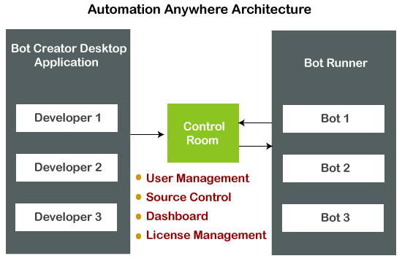

There are two versions of automation anywhere, the first one being the community edition: - It is free for all. The second one is the Enterprise edition with enhanced capabilities, with a premium range.

## Other Important Products of Automation Anywhere

**Bot Insights**

Bot Insight is a tool that allows users to analyze the performance of bots. It displays graphs and statistics to measure each bot's performance. It also enables users to calculate the time that a user has saved with automation. It is said to be the first analytics solution used for bots. Bot Insights uses real-time business insights with digital workforce performance.

**Bot Farm**

Bot Farm is a tool used for the expansion of the number of RPA bots. It is integrated with the Enterprise edition of Automation Anywhere. Bot Farm can also scale the capacity of the digital workforce with a single-click deployment anytime from anywhere. It allows users to develop, deploy, and manage hundreds or thousands of bots, ensuring elasticity and scalability.

**Bot Store**

Bot Store is the first digital marketplace that contains several pre-built bots for different business automation tasks. It allows enterprises to deploy different bots such as application bots, process bots, and cognitive bots in a short period.

There are three types of bots used in Automation Anywhere:

Task bot

Meta bot

IQ bot

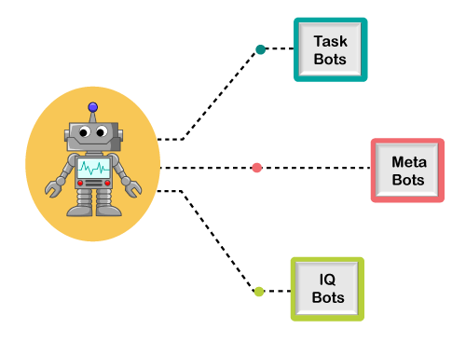

Task Bots

Task bots are bots that are used to automate rule-based, repetitive tasks. Task bots are usually beneficial in document administration, claims management, HR department, IT, etc. They enhance productivity, error reduction, and cost-saving.

Meta Bots

Meta bots are known as automation building blocks that facilitate scalability with next-generation integration. These are designed for complex, scalable processes. If there is a requirement for any change in the process, we have to perform some edits to the bot. The changes will be automatically applied to all the processes linked with that specific bot.

IQ Bots

IQ Bot is an advanced tool that includes the capability of thinking like a human. IQ bots are also referred to as Cognitive bots. These bots are developed to learn on their own and perform the tasks according to them. IQ bots use advanced cognitive technology and advanced artificial technologies that enable users to experience the power of automation. These bots include features like self-learning, decision-making, subject matter expertise, etc. These bots can extract data from semi-structured and unstructured data.

## What Processes we can automate with Automation Anywhere?

Almost all the repetitive and rule-based digital processes can be controlled by Automation Anywhere. It uses GUI to control the processes just like a human. It can also automate complex processes and efficiently complete them.

Some of the important processes that can be automated using Automation Anywhere are:

Data extraction and submission

Data comparison and validation

All Windows and web-based user actions

Navigation through the web, windows, cloud, legacy systems

Rule-based decisions

# Projects

* 1. LinkedIn Automation

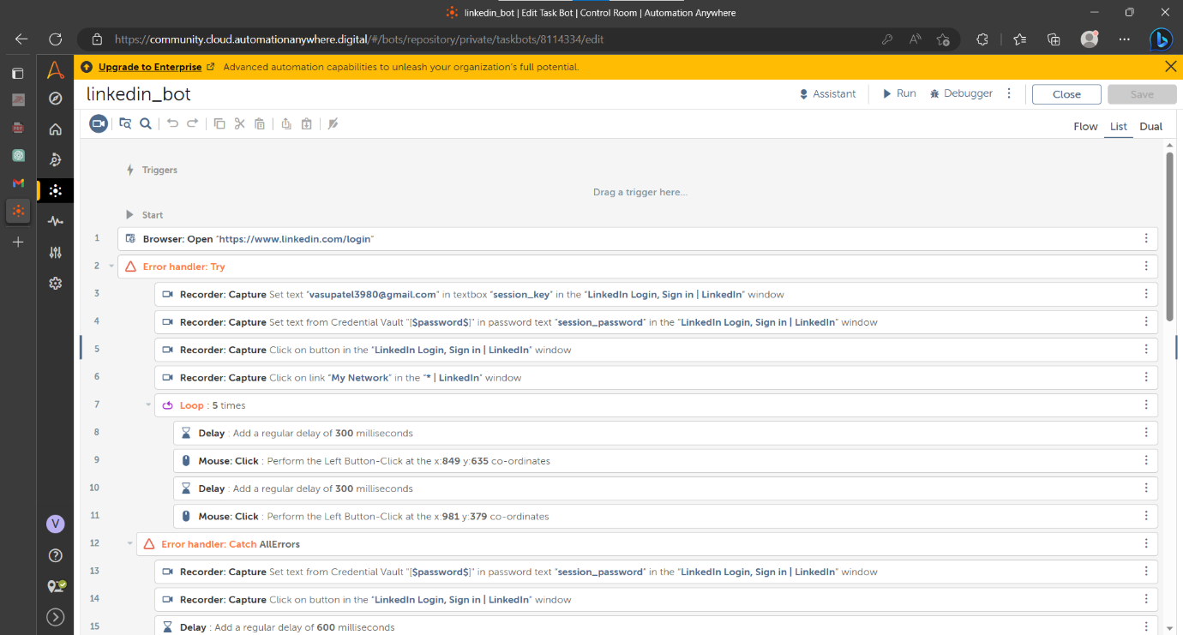

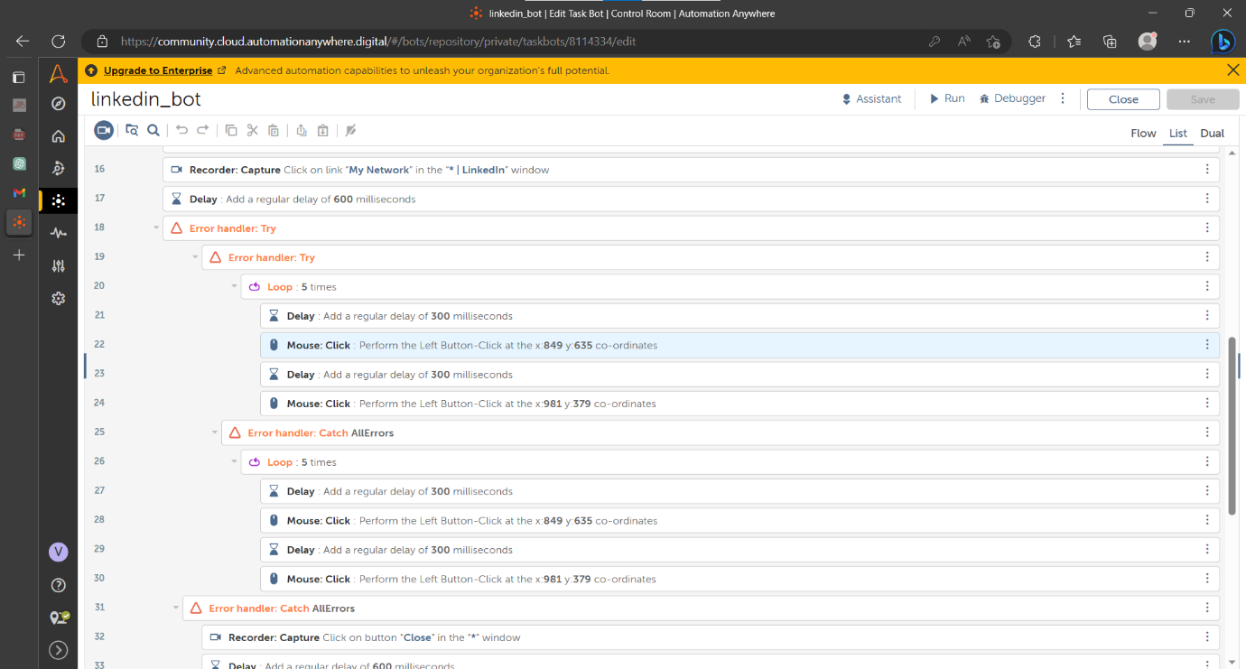

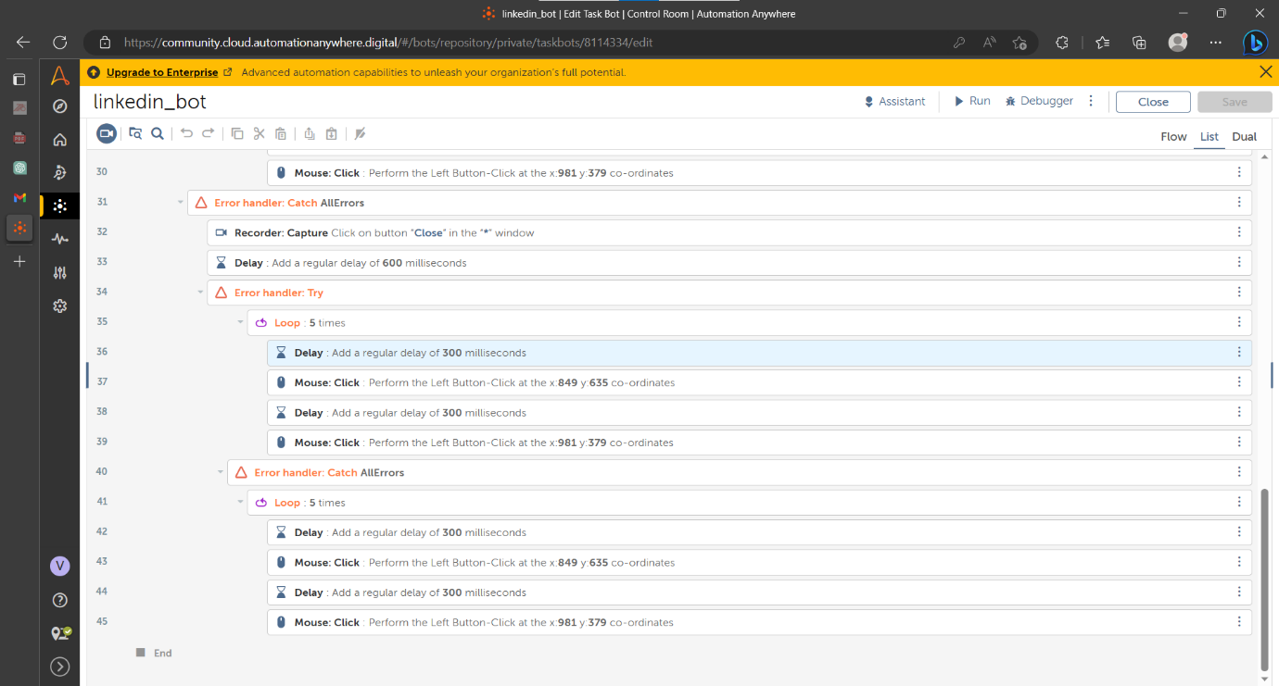

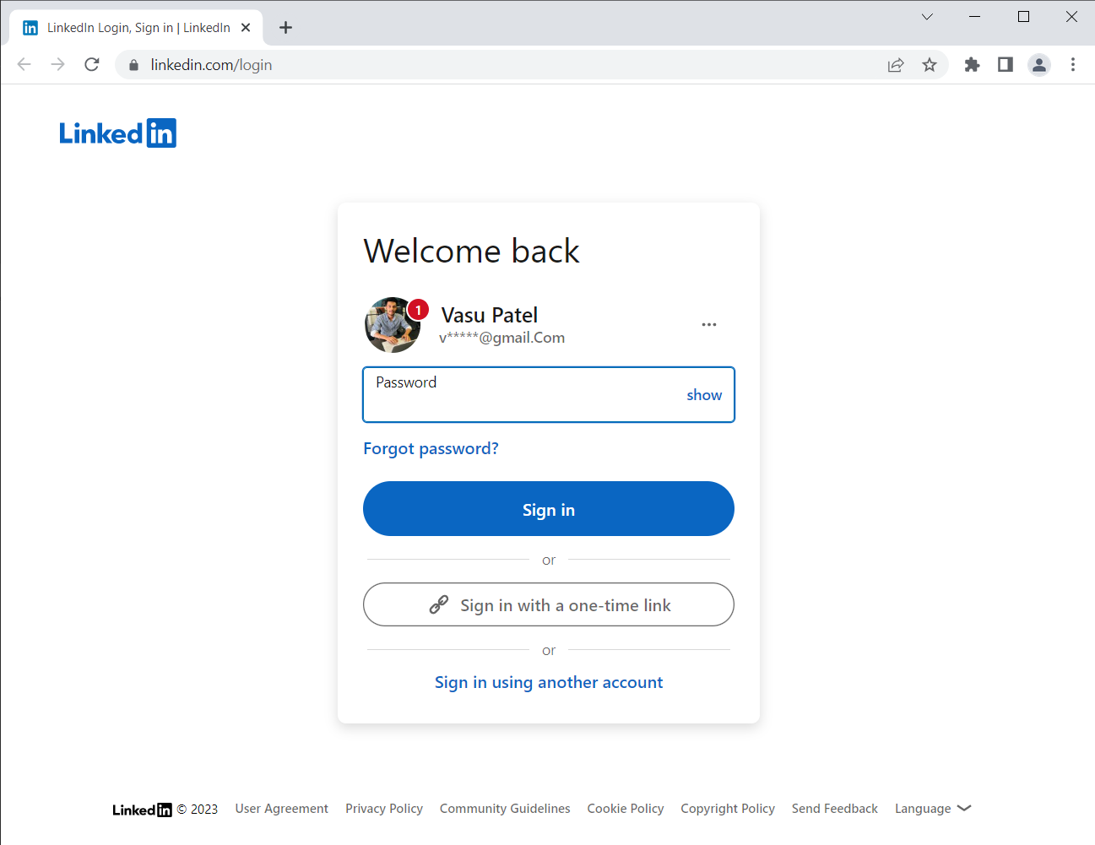

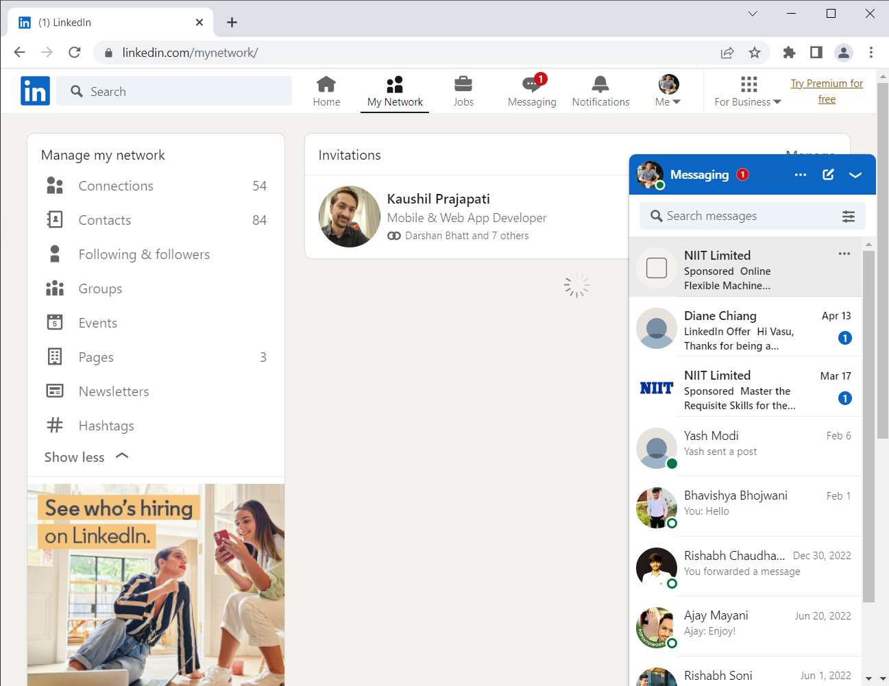

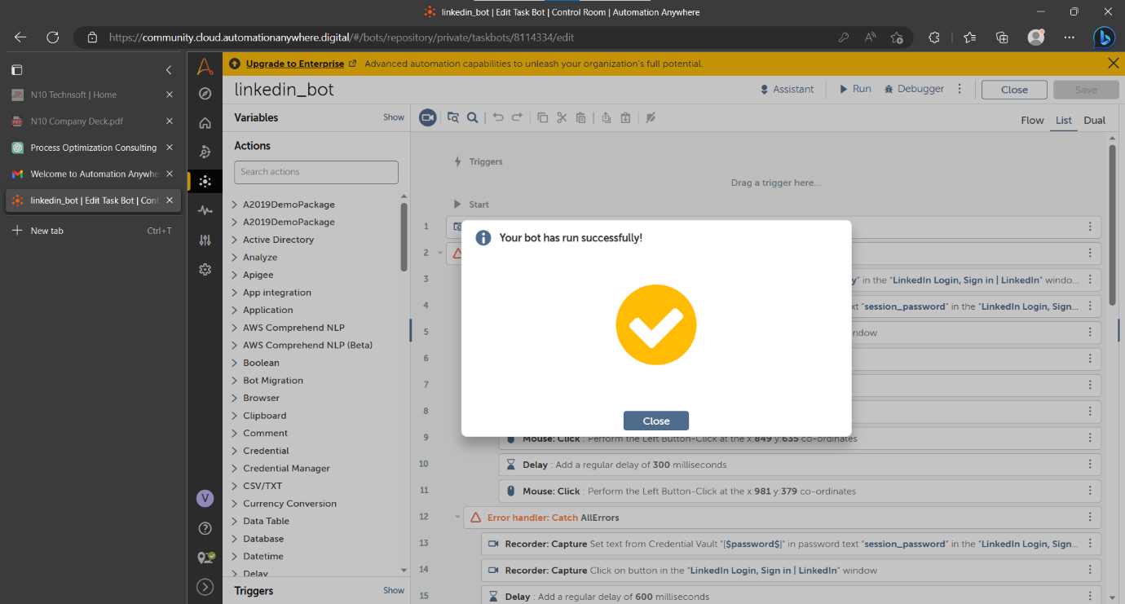

## Data analysis

First, we give the data to bot

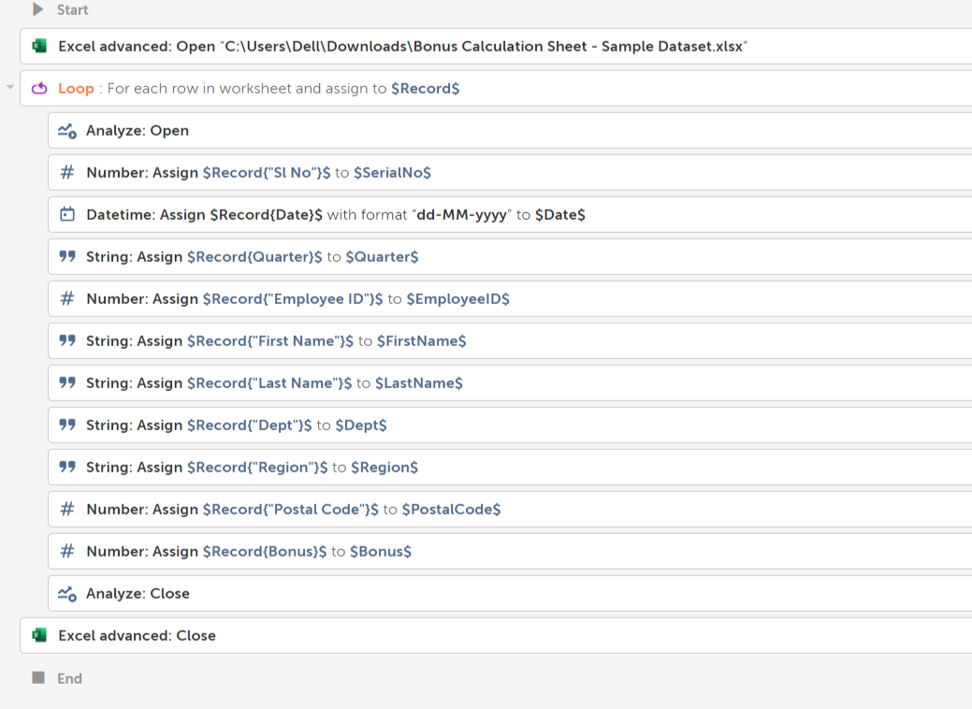

RPA automatically makes the dashboard and gives output

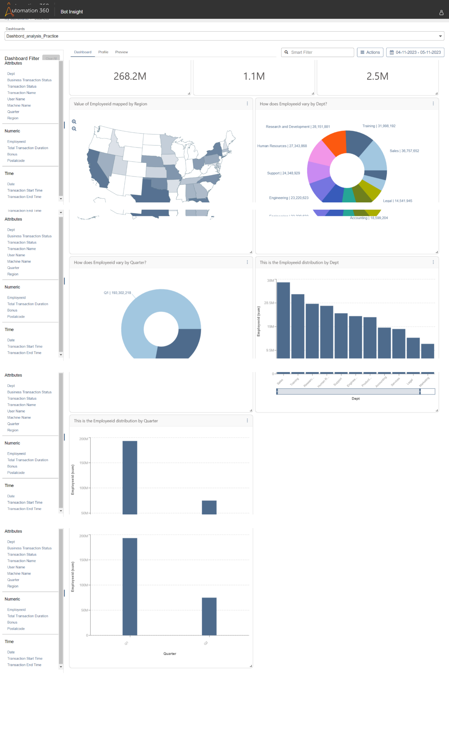

Calculate the total minute attended by employees using RPA

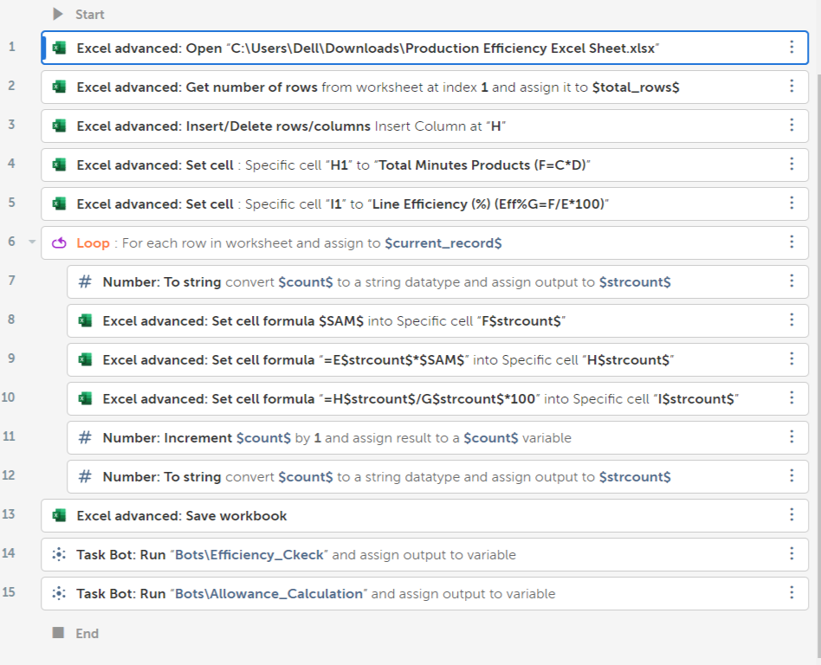

Here we see that output in the K and I column

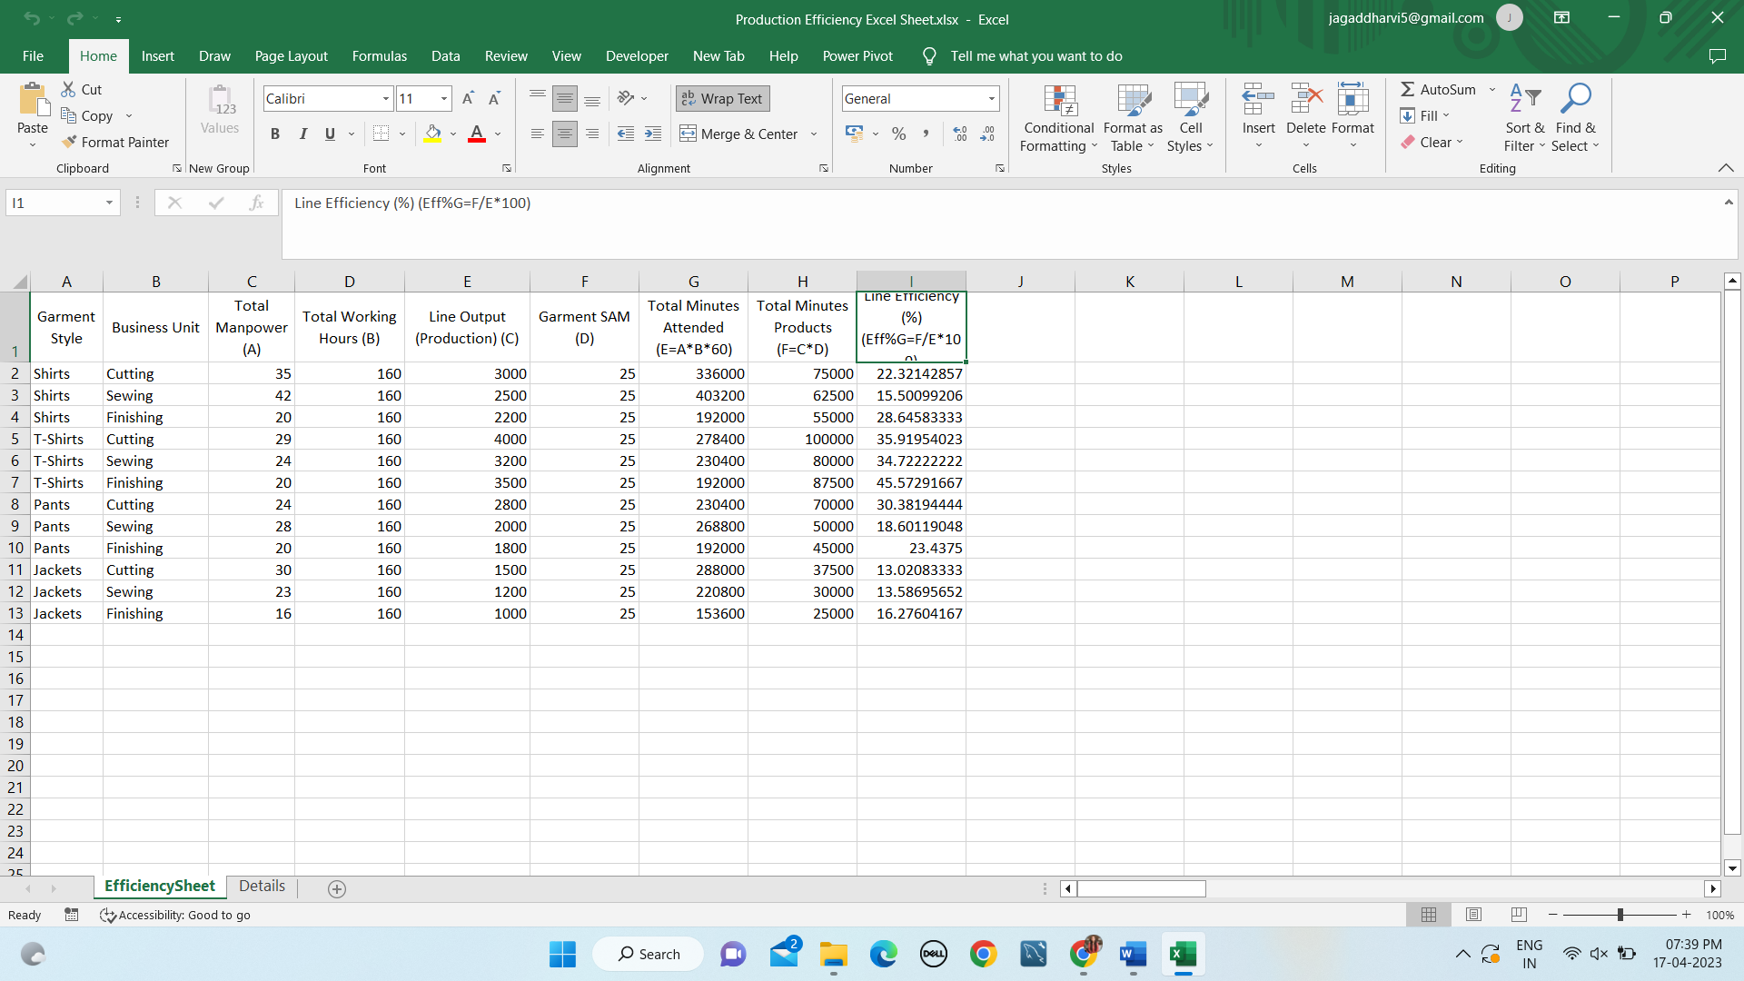

Inventory Management

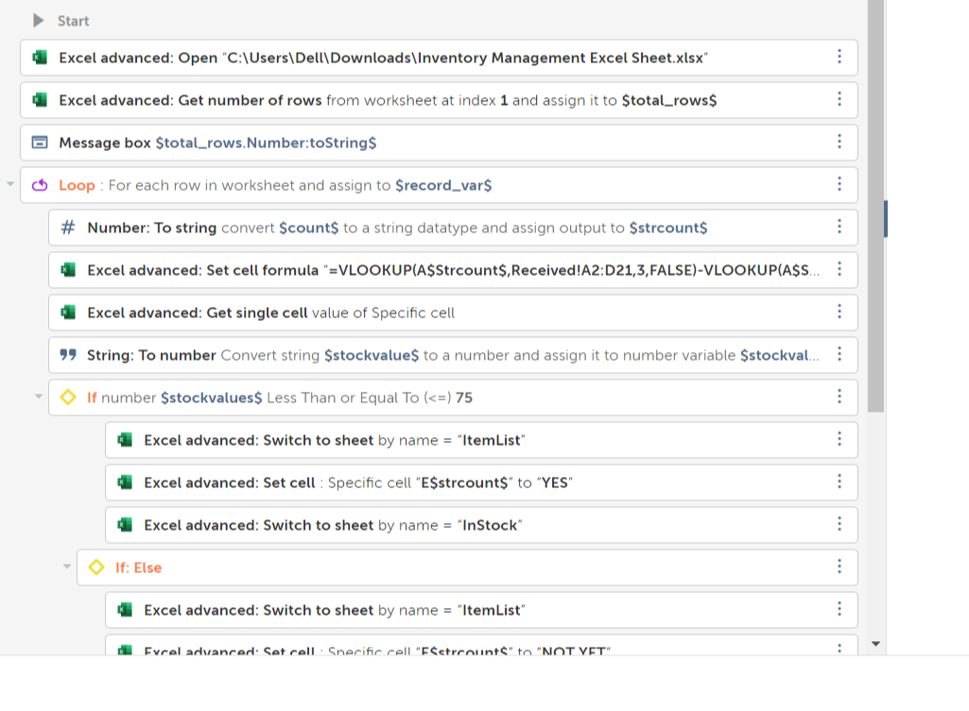

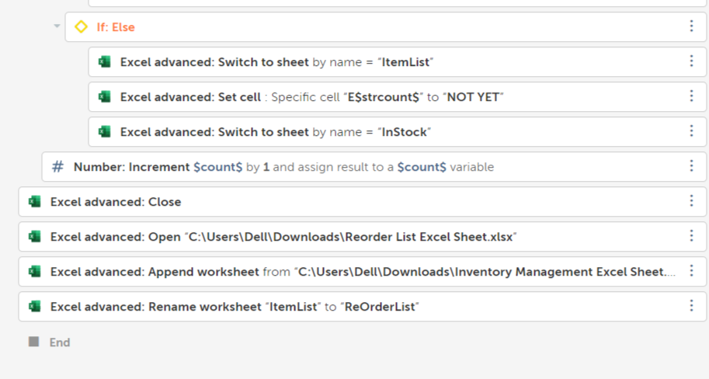

Output:

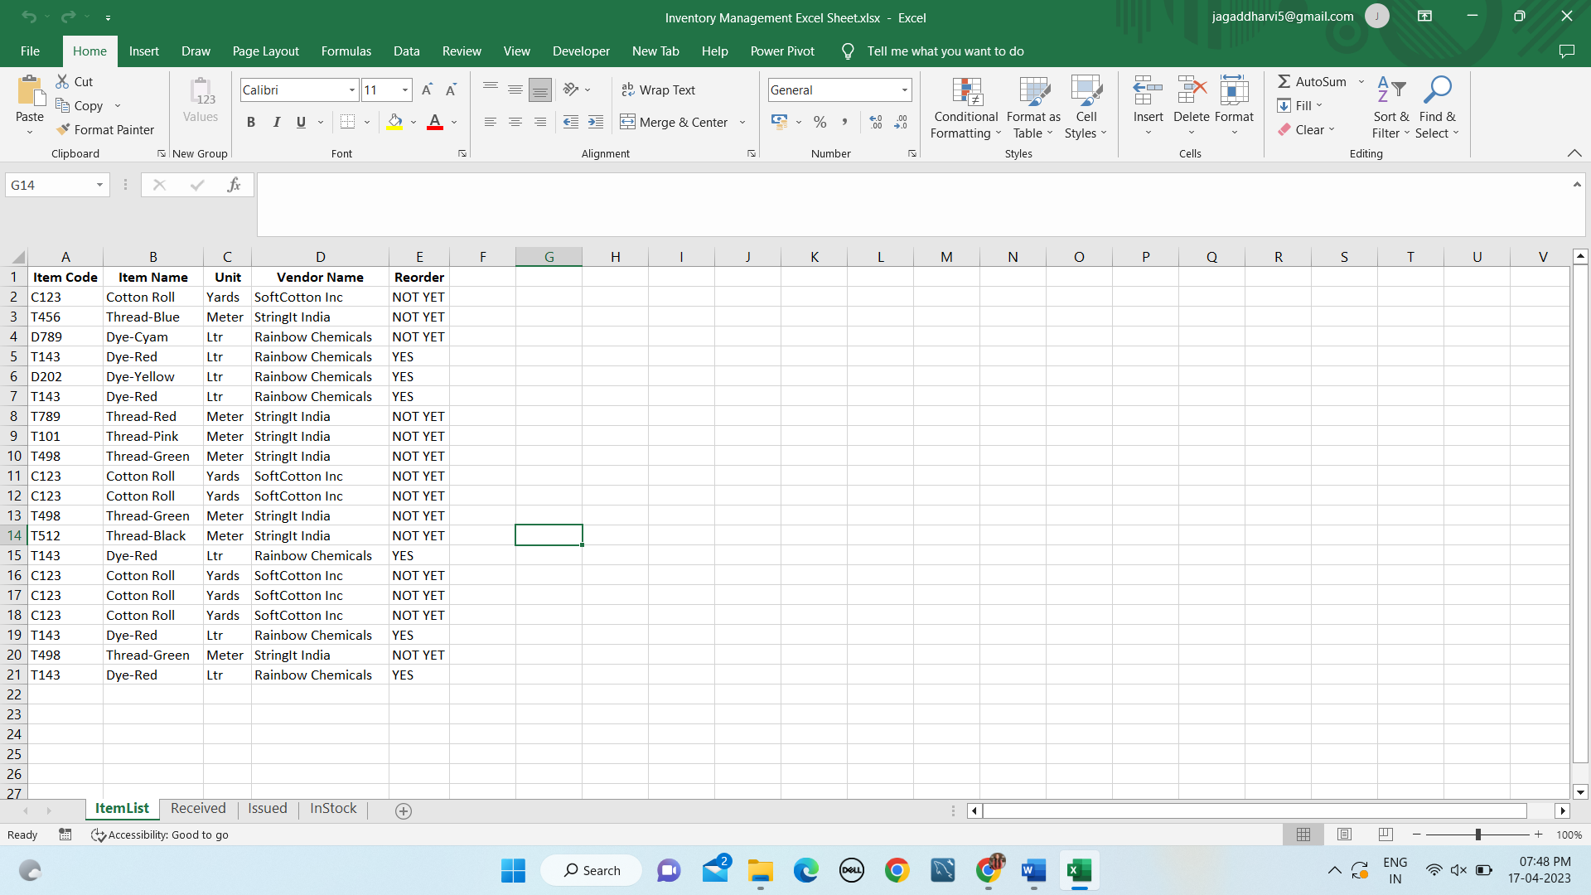

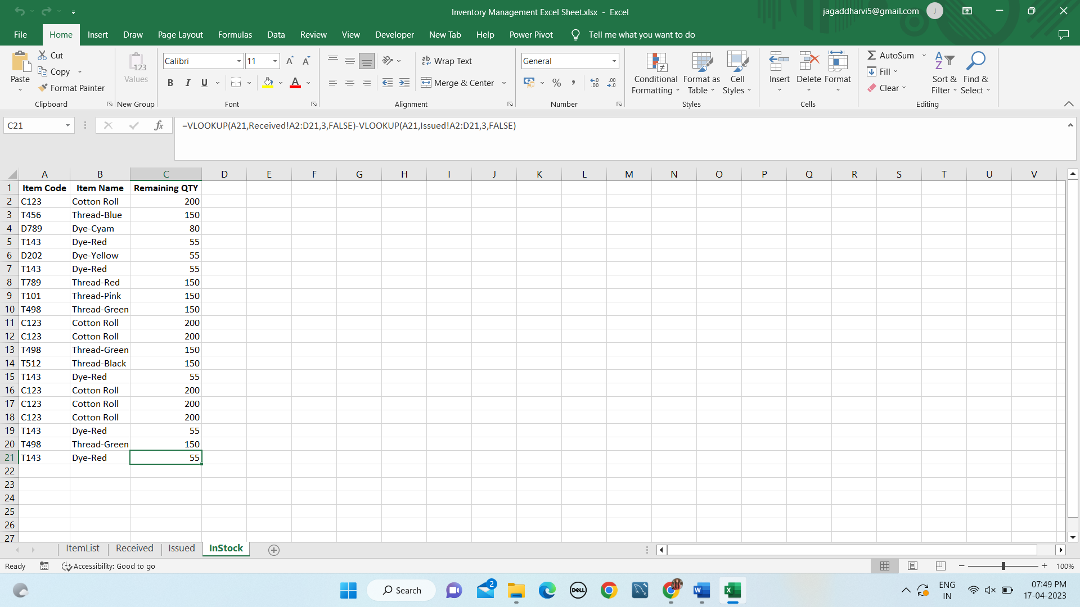

* 1. RPA Problems

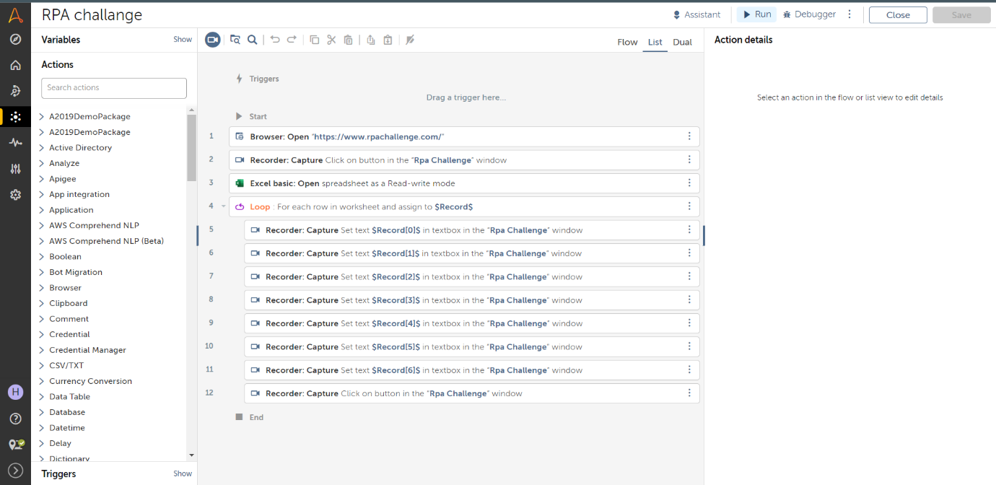

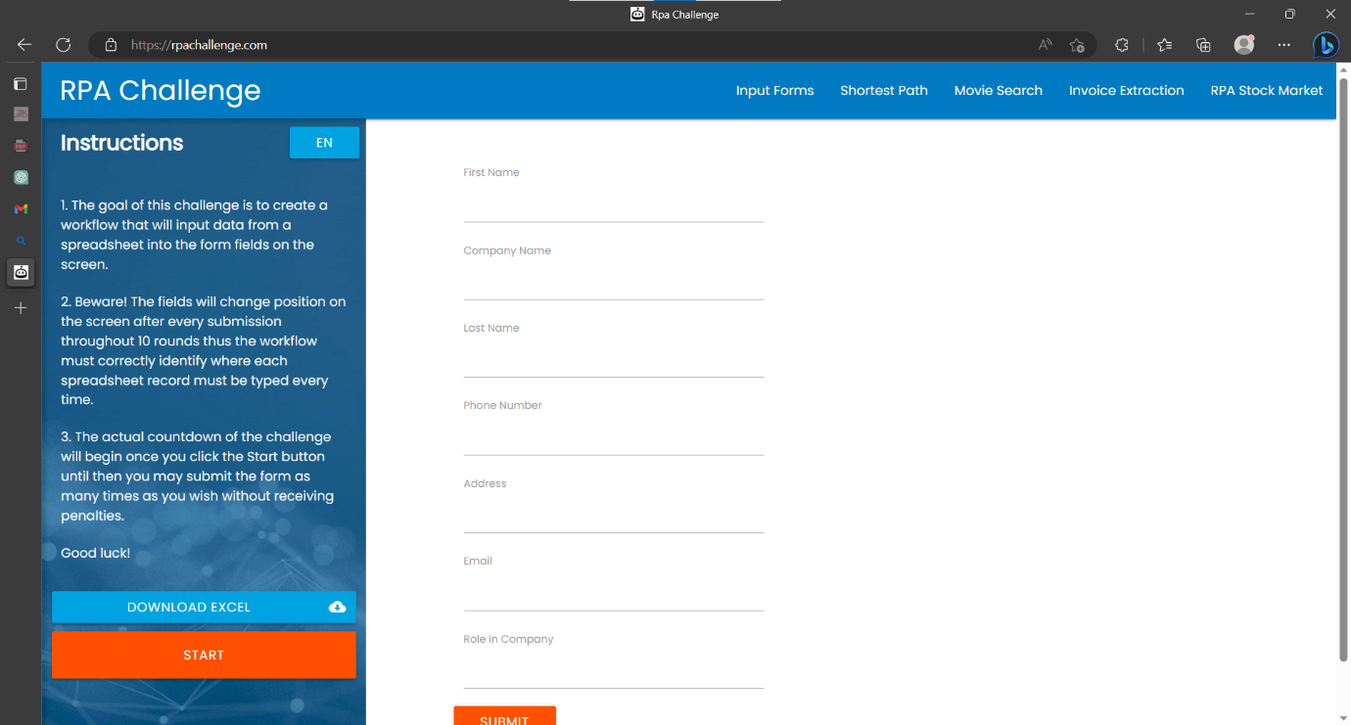

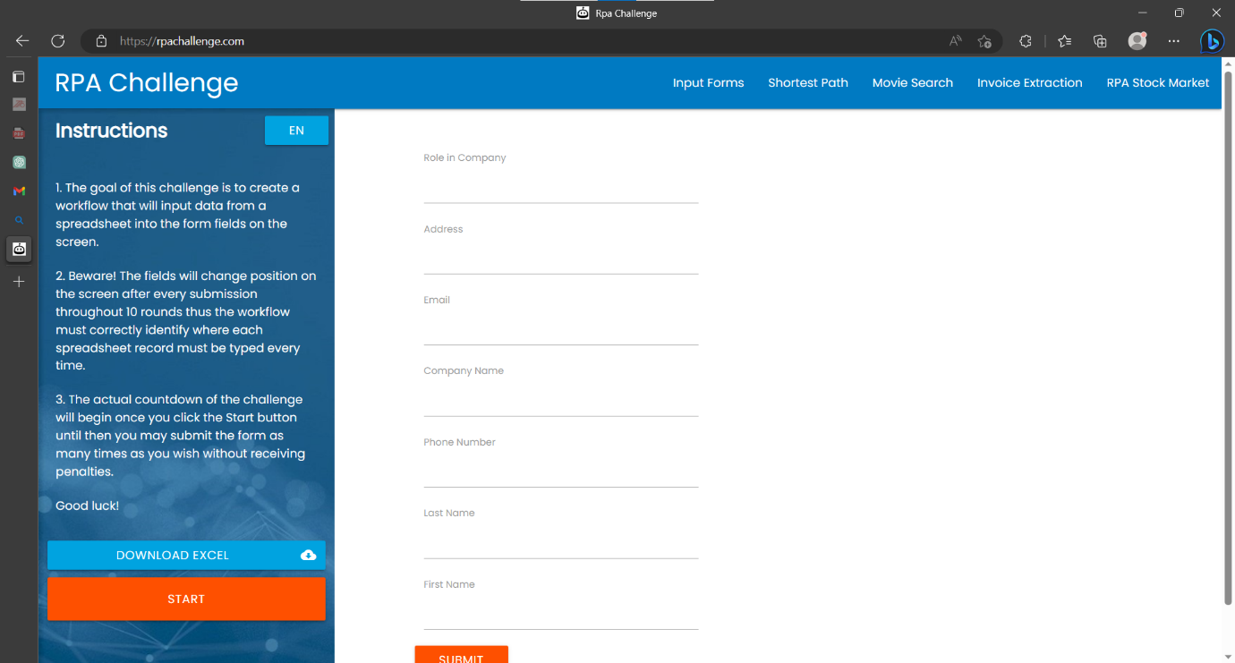

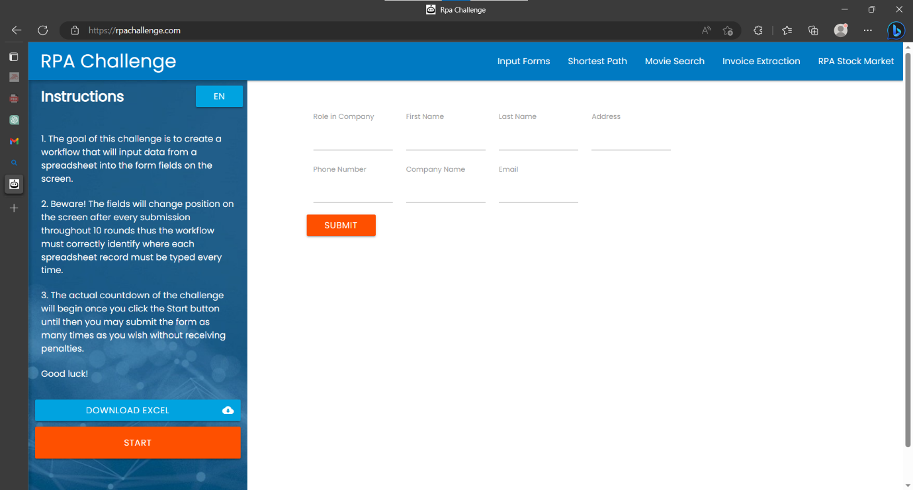

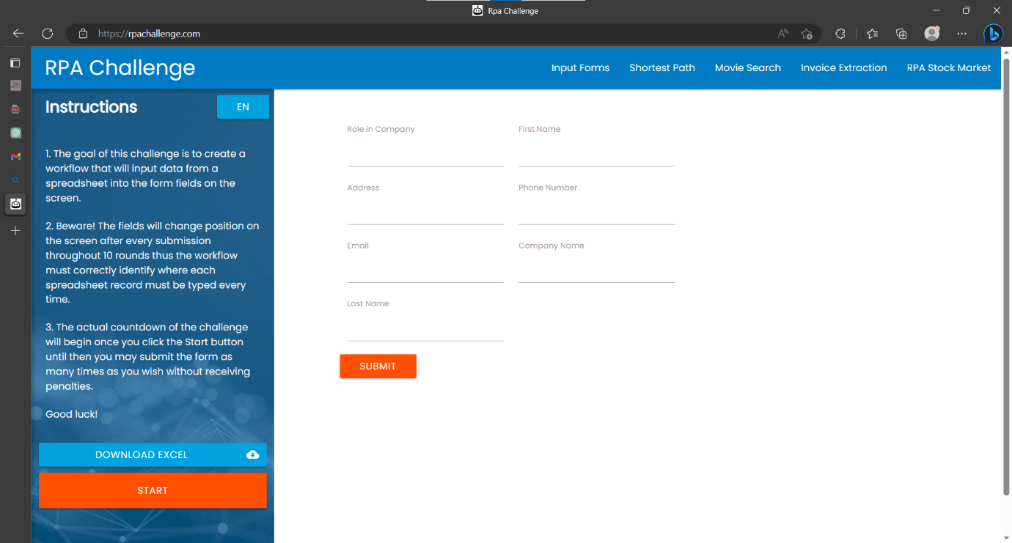

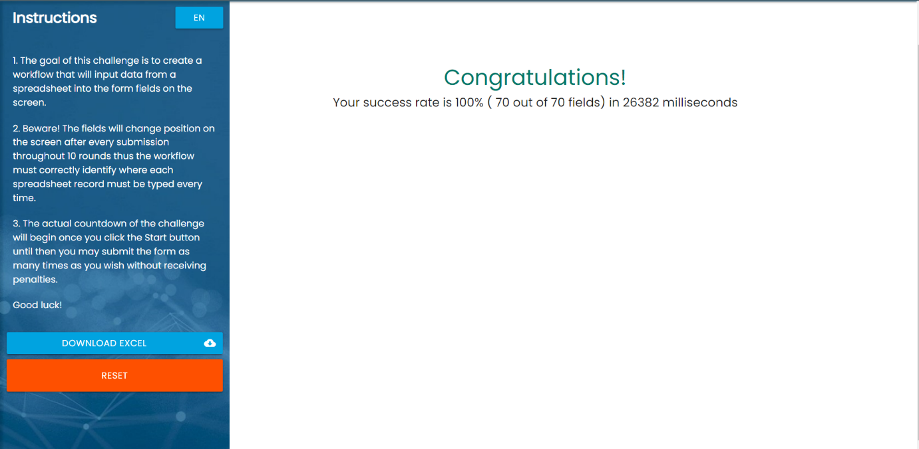

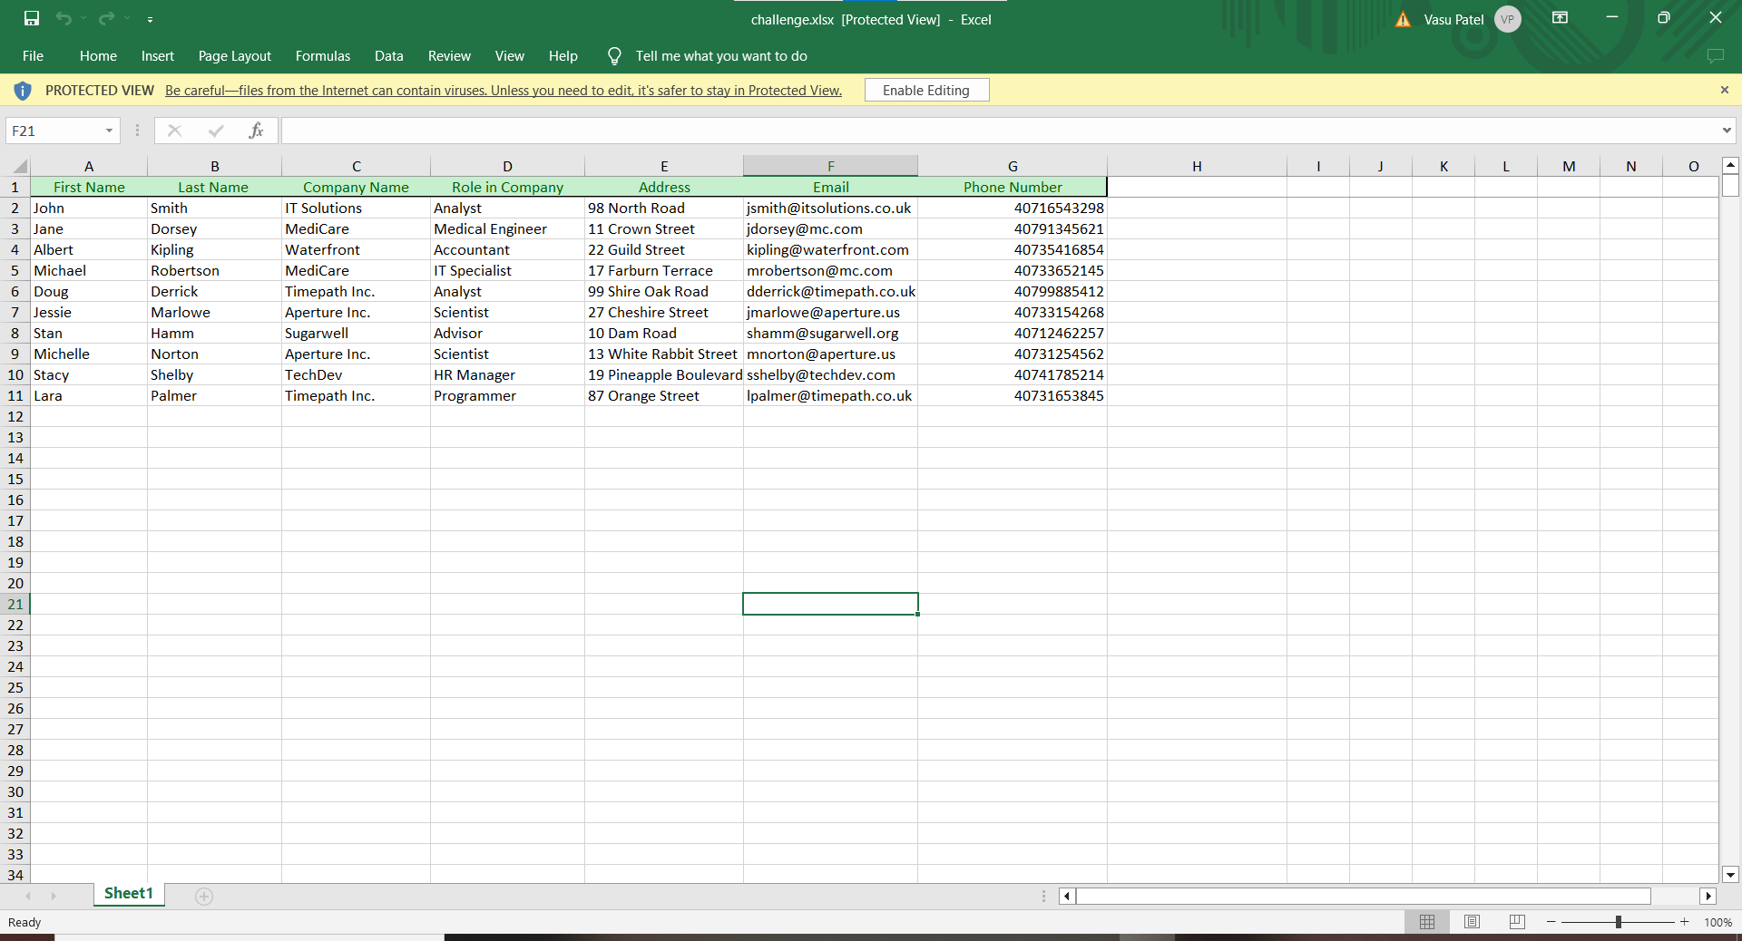

* 1. Data Scraping from Stocks Markets



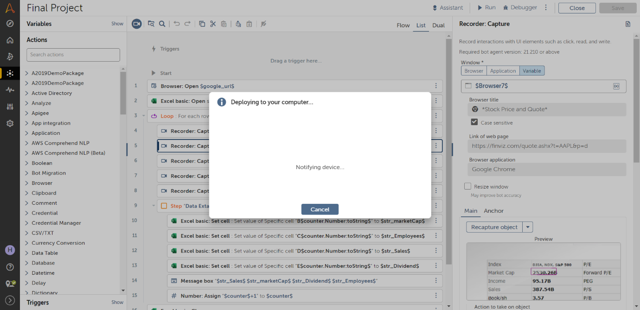

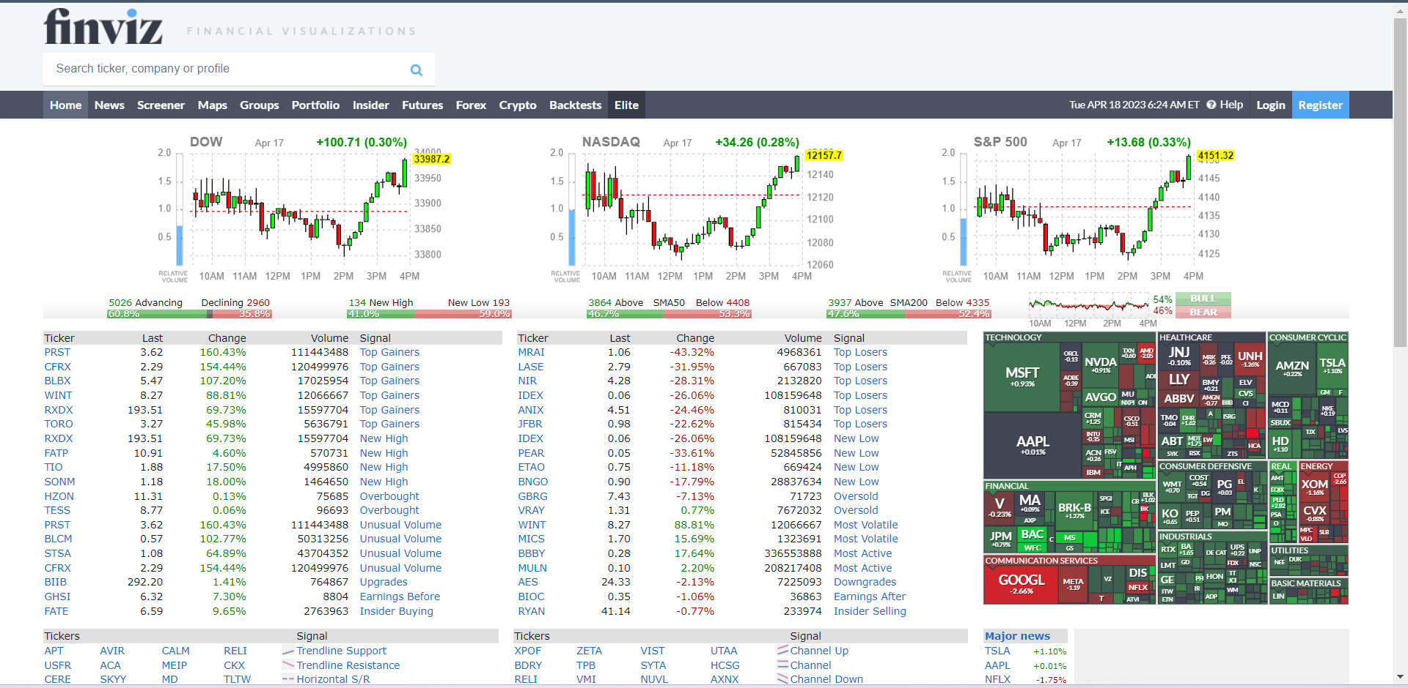

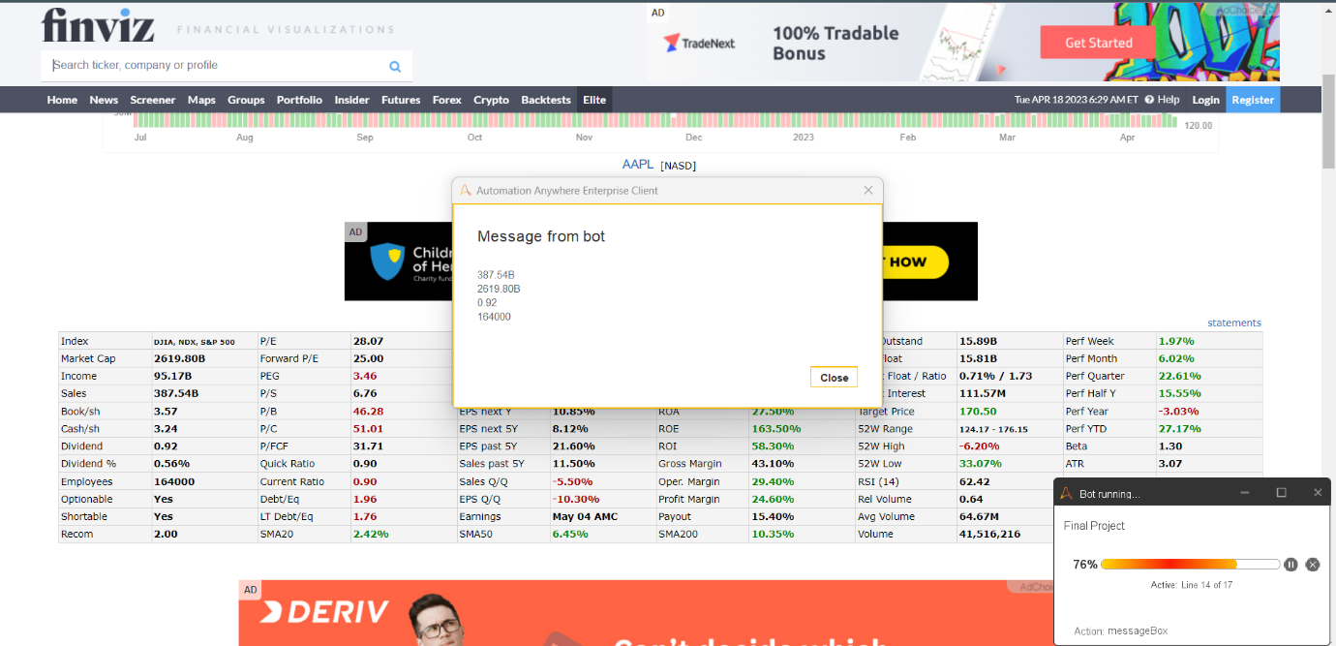

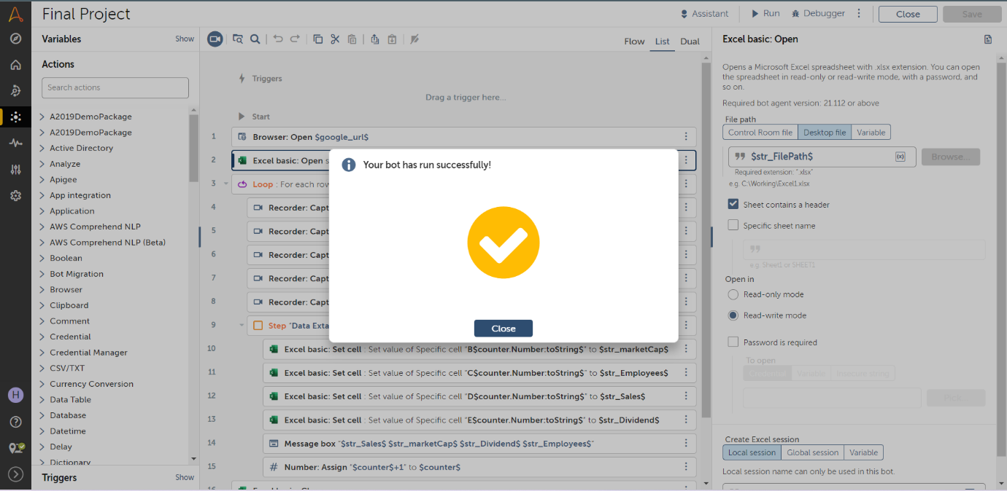

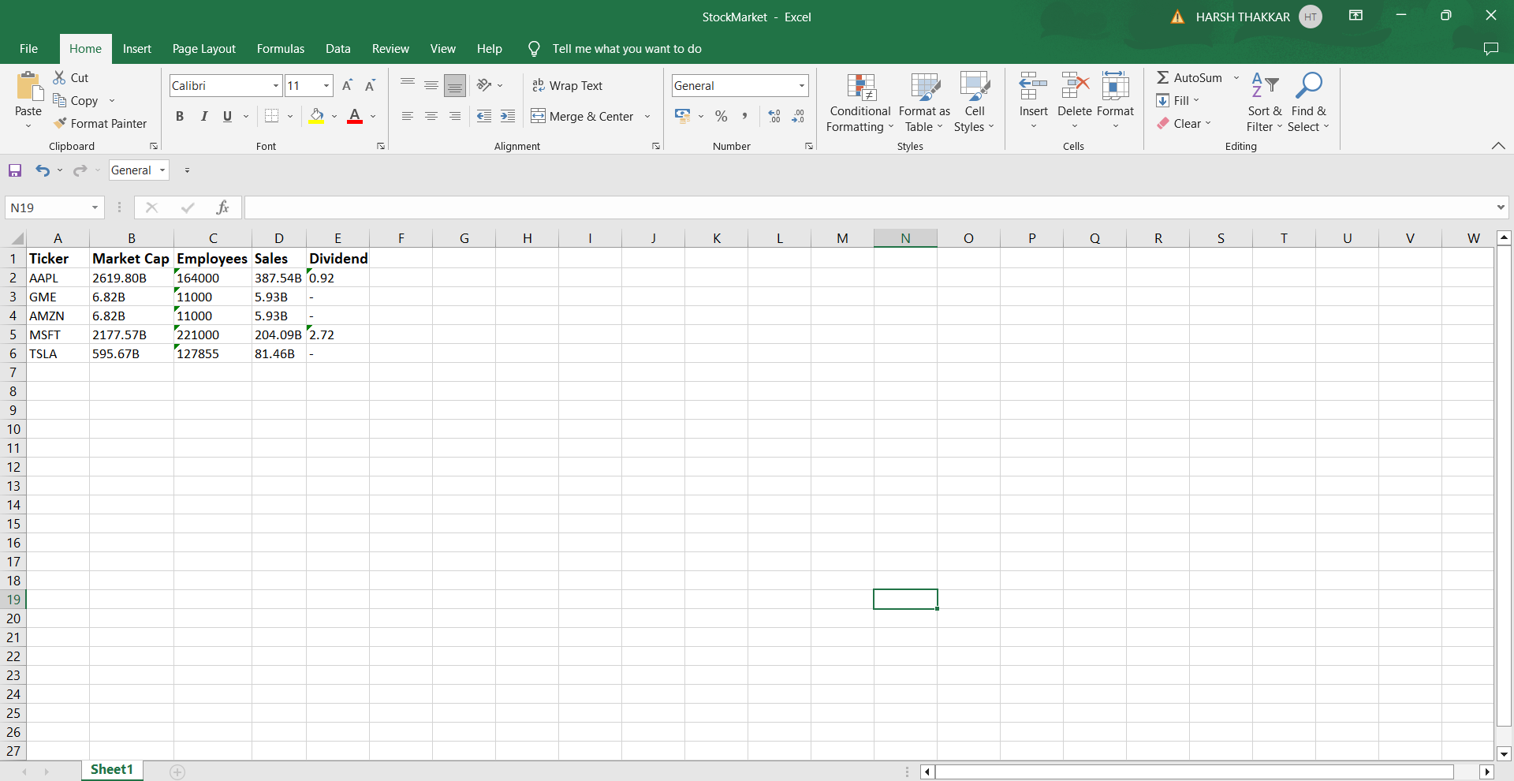

## Data Scraping

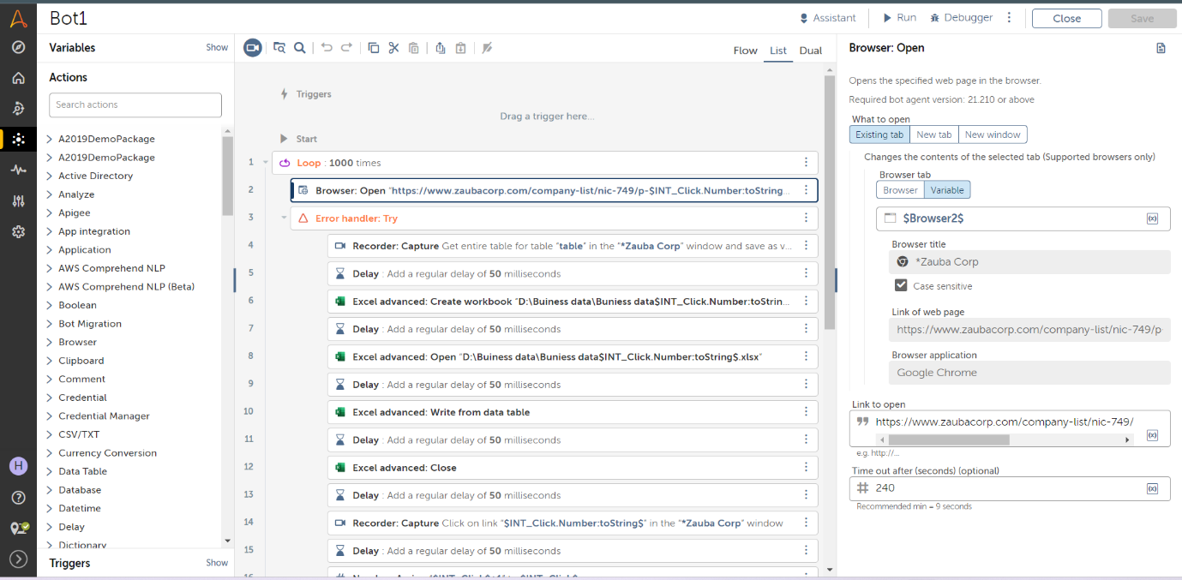

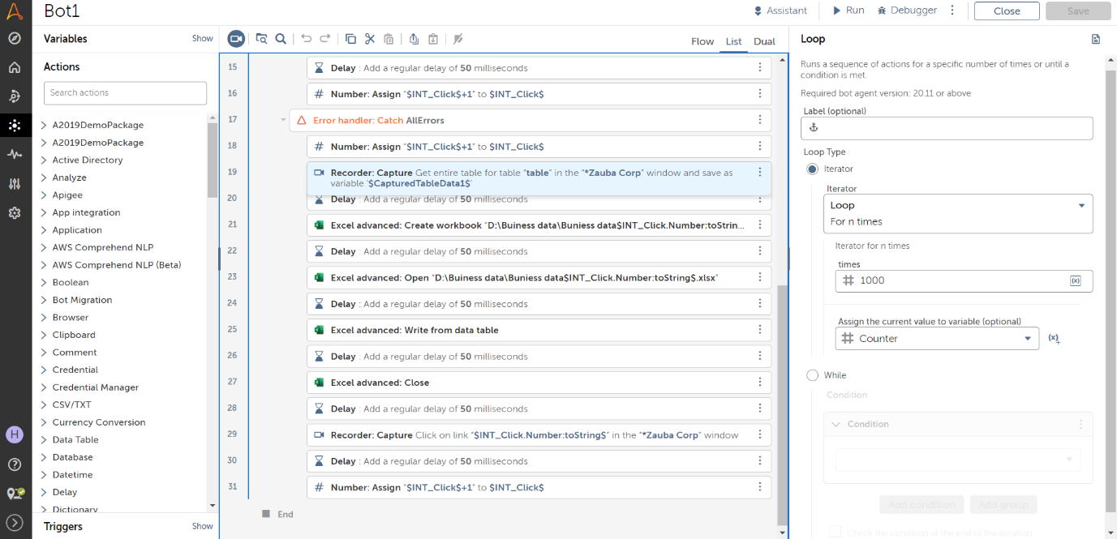

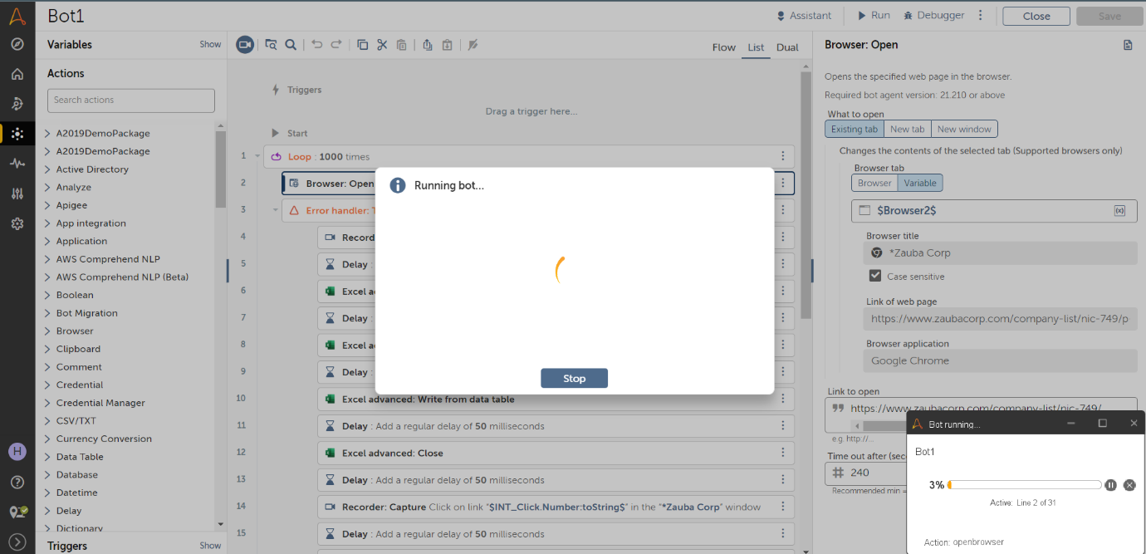

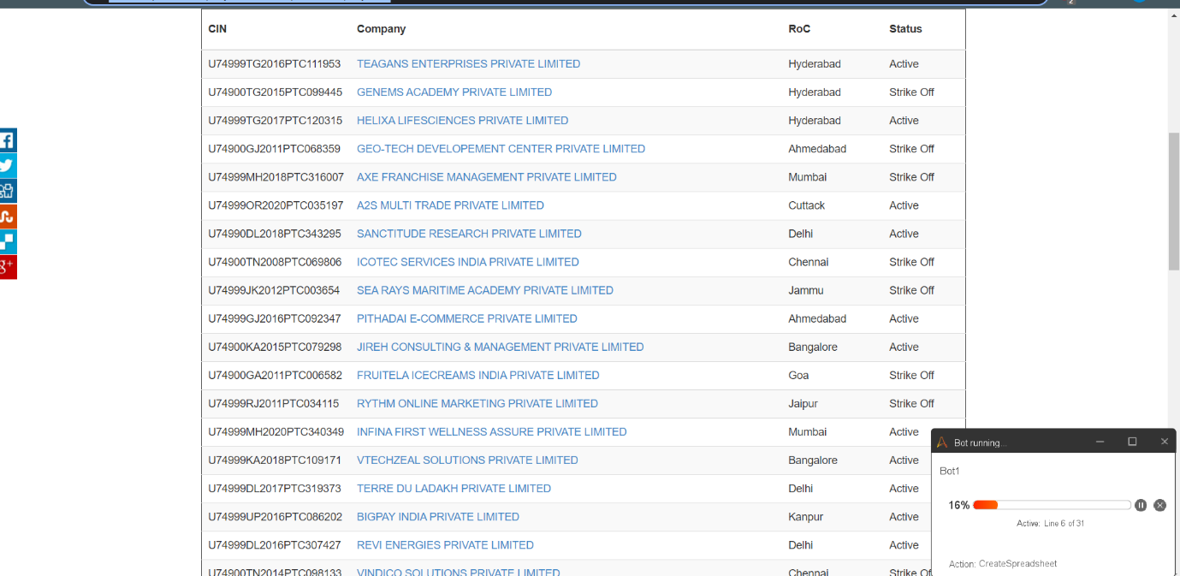

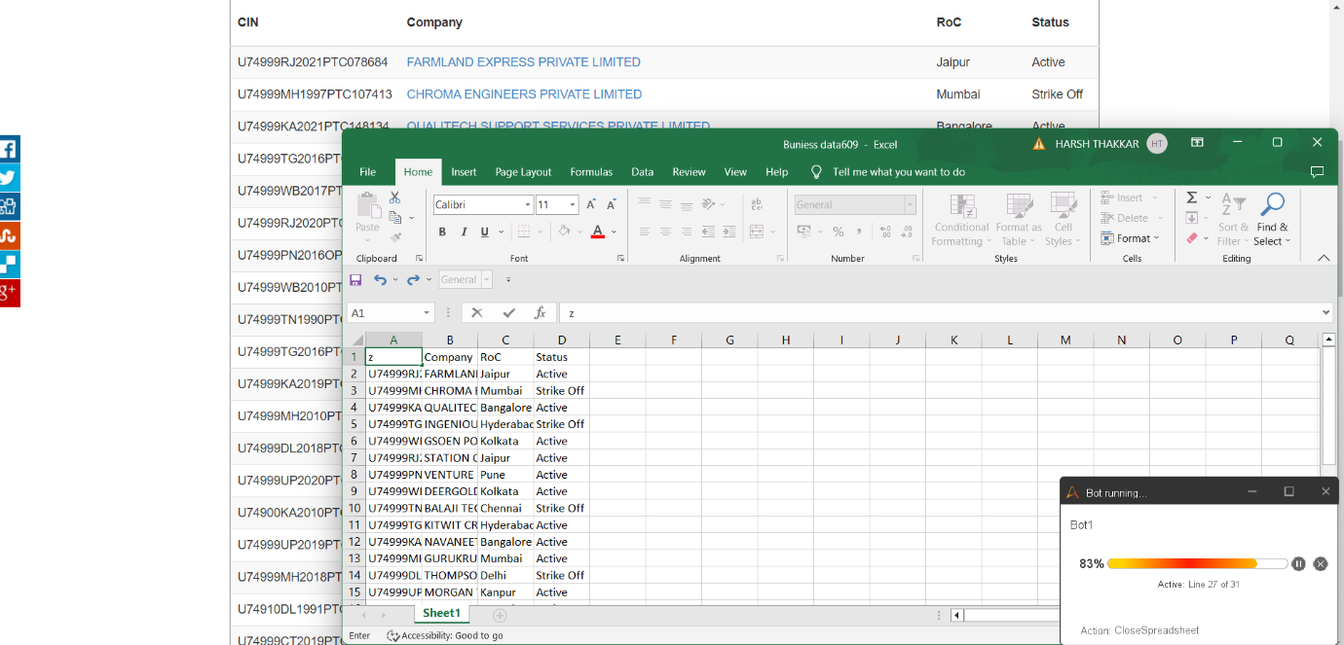

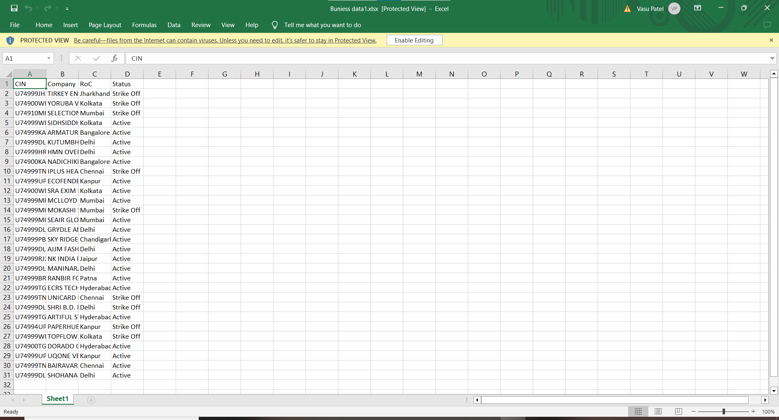

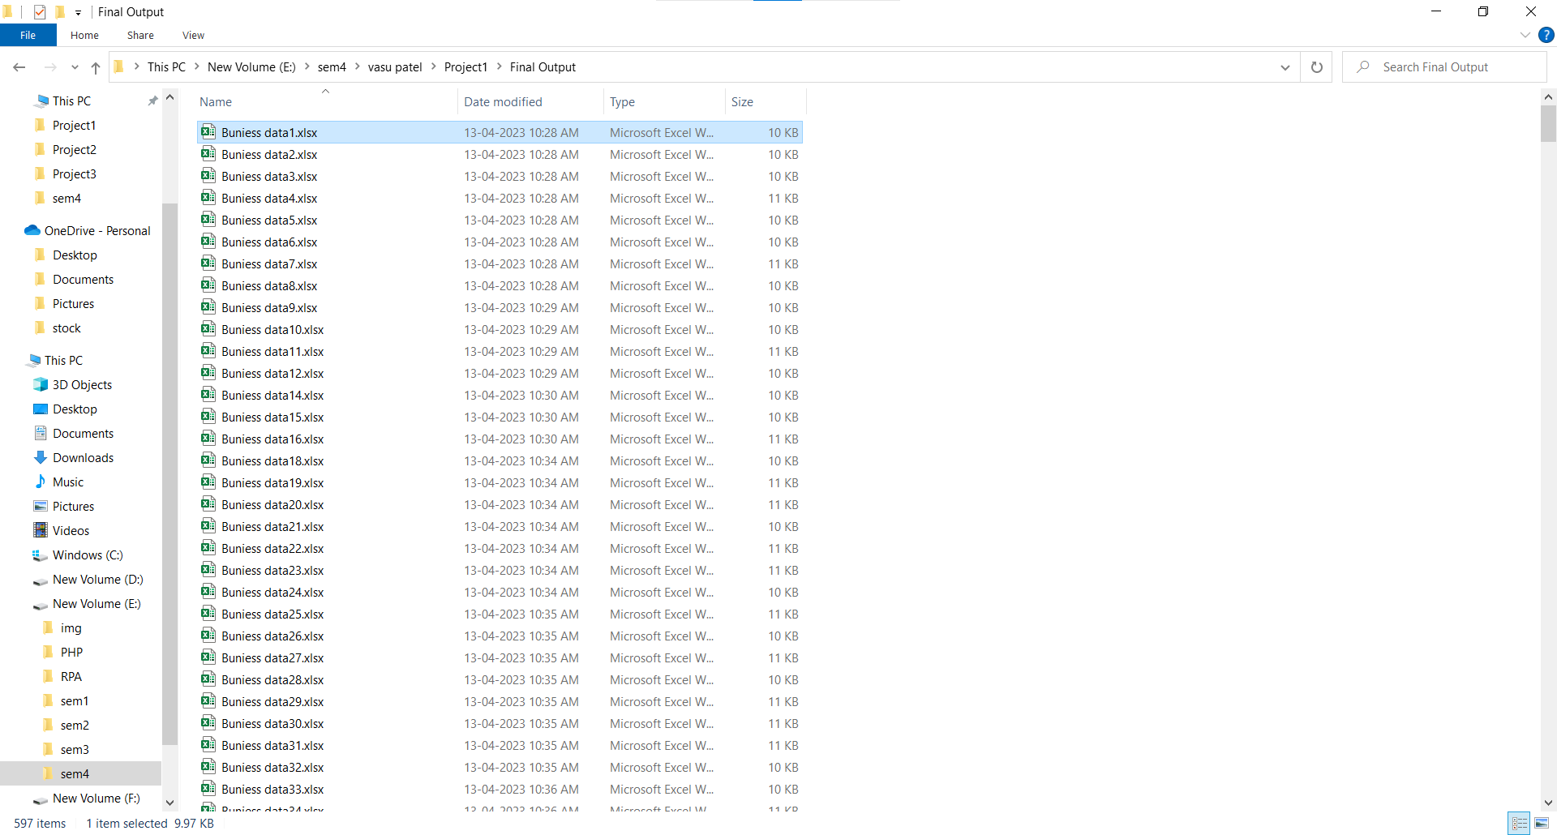

## Android Application(Ace Tennis )

We are currently working on an exciting new project which involves the development of a mobile application for a client. The focus of this application is to create a platform where players can register themselves and book courts for play.

One of the key features of the application is the events page, which will be a news feed about upcoming and past events. This will enable players to stay up-to-date with the latest events and competitions, and plan their schedules accordingly.

Another important aspect of the application is the membership feature. Users will be able to choose from group membership or private membership options, which will give them access to various benefits and features within the application.

Additionally, the application will include a leaderboard feature, which will rank academy players based on their performance in competitions held at the academy. This will provide players with an added level of competition and motivation to improve their skills.

Overall, this mobile application is designed to provide a comprehensive platform for players to register, book courts, participate in events, and track their progress. With its innovative features and user-friendly interface, we are confident that this application will become a go-to resource for players of all levels.

One of the primary features of the mobile application we are developing for our client is the booking system. Users will be able to select their preferred court and time slot, and make a secure online payment to confirm their booking.

This booking system will streamline the court reservation process, saving players time and effort. Users will be able to view the availability of courts in real-time, and book a court with just a few taps on their mobile devices. The payment process will also be quick and convenient, with multiple payment options available for users to choose from.

To ensure the security of user data and transactions, we will be implementing industry-standard encryption protocols and security measures throughout the booking process. This will give users peace of mind, knowing that their personal and financial information is being protected at all times.

Overall, the booking system will be a key feature of the mobile application, providing users with a seamless and hassle-free way to reserve courts and enjoy their favorite sport.

## 

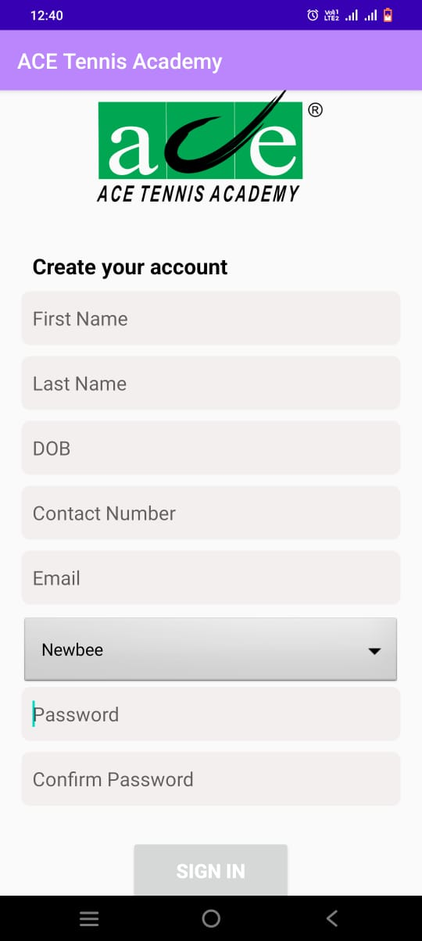 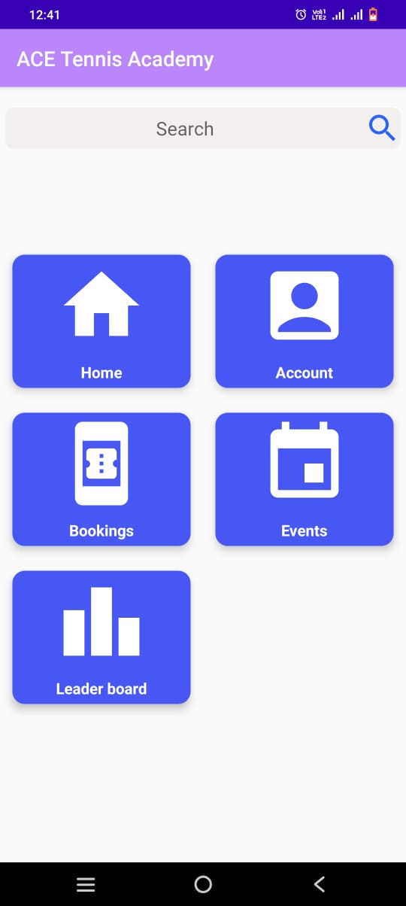

## E-Contractors(Admin)

Let me tell you about how we created our website using CodeIgniter and a template engine, all powered by the PHP programming language.

To begin, we chose to use CodeIgniter as our framework of choice because of its simplicity and ease of use. It provides a solid foundation for building scalable and secure web applications.

We also decided to use a template engine to make it easier to manage the look and feel of our website. By using a template engine, we were able to create reusable components that could be easily integrated into our website.

Next, we began by defining the basic structure of our website. We created a set of templates that defined the layout and design of our pages, including the header, footer, and sidebar. These templates were then used to create the individual pages of our website.

We used PHP to define the logic of our website, including data retrieval from our database and handling user input. We used CodeIgniter's built-in model-view-controller (MVC) architecture to keep our code organized and easy to manage.

In addition, we implemented various security measures to protect our website from common vulnerabilities, such as SQL injection and cross-site scripting (XSS) attacks.

Once the website was up and running, we continued to refine and improve it based on user feedback and analytics data. We added new features and functionality, optimized the website for speed and performance, and made sure that it was accessible and easy to use for all users.

Overall, by using CodeIgniter and a template engine powered by PHP, we were able to create a scalable, secure, and user-friendly website that met all of our needs and the needs of our users.

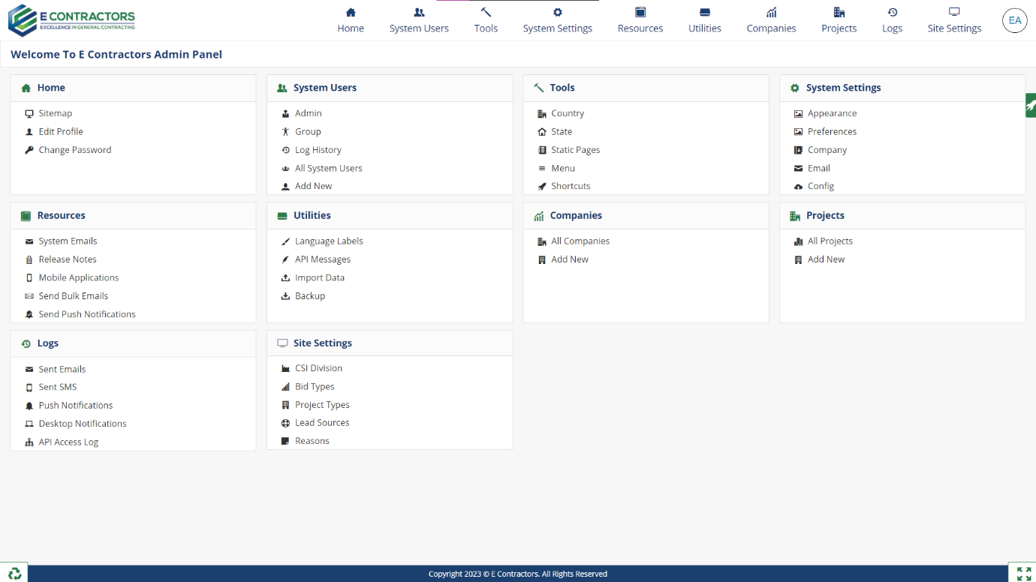

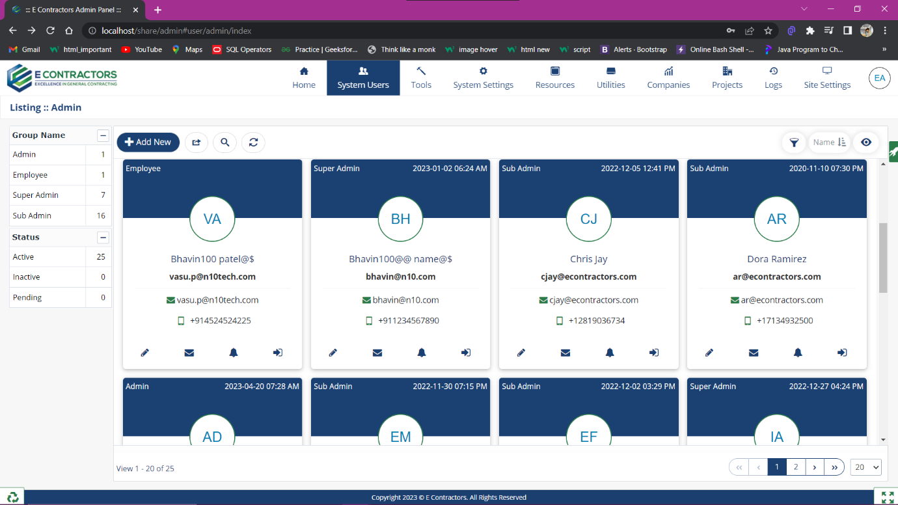

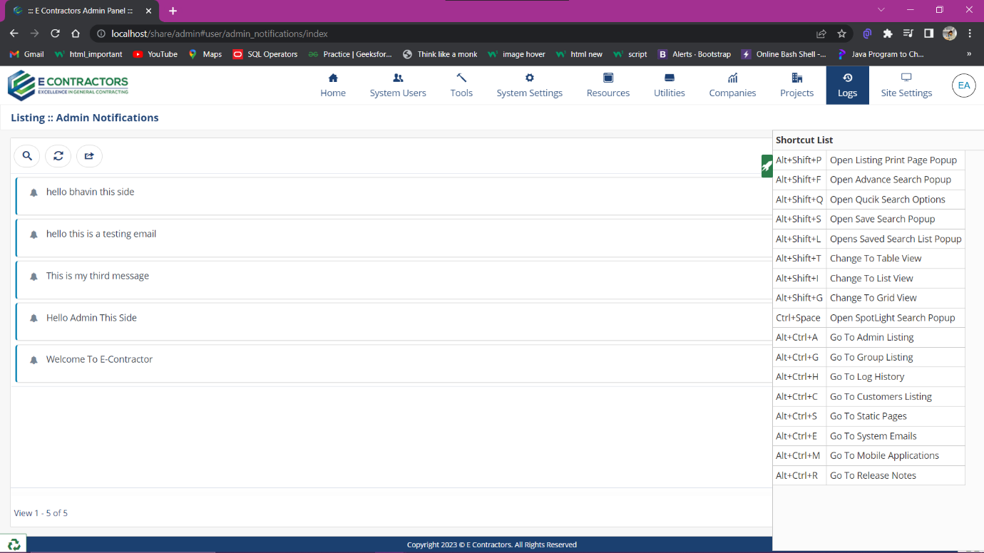

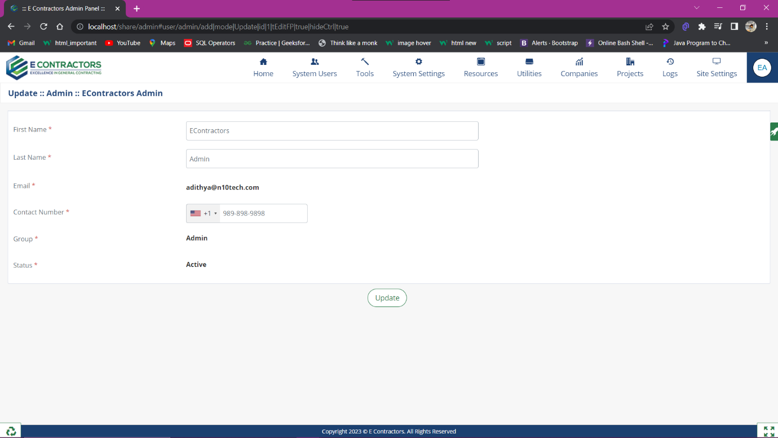

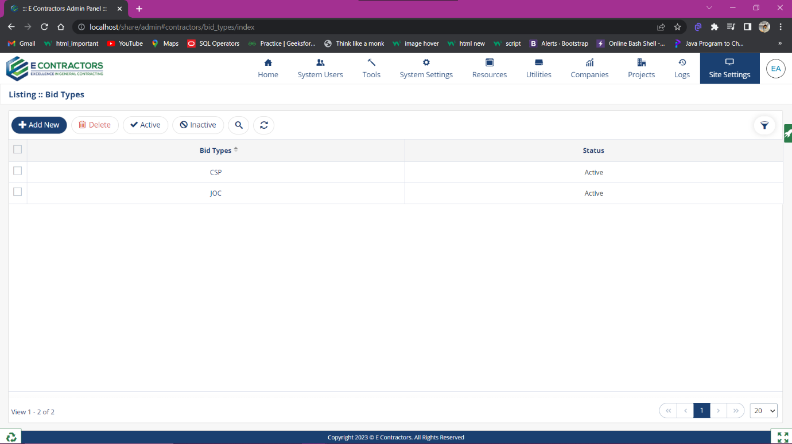

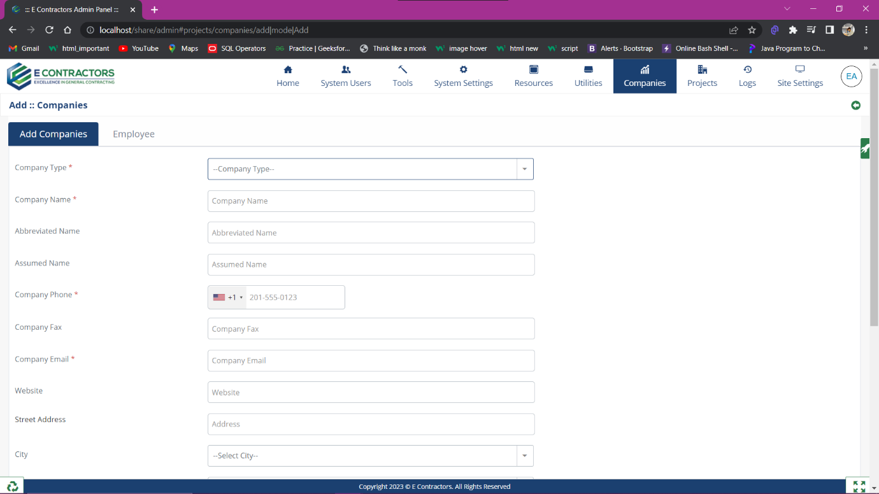

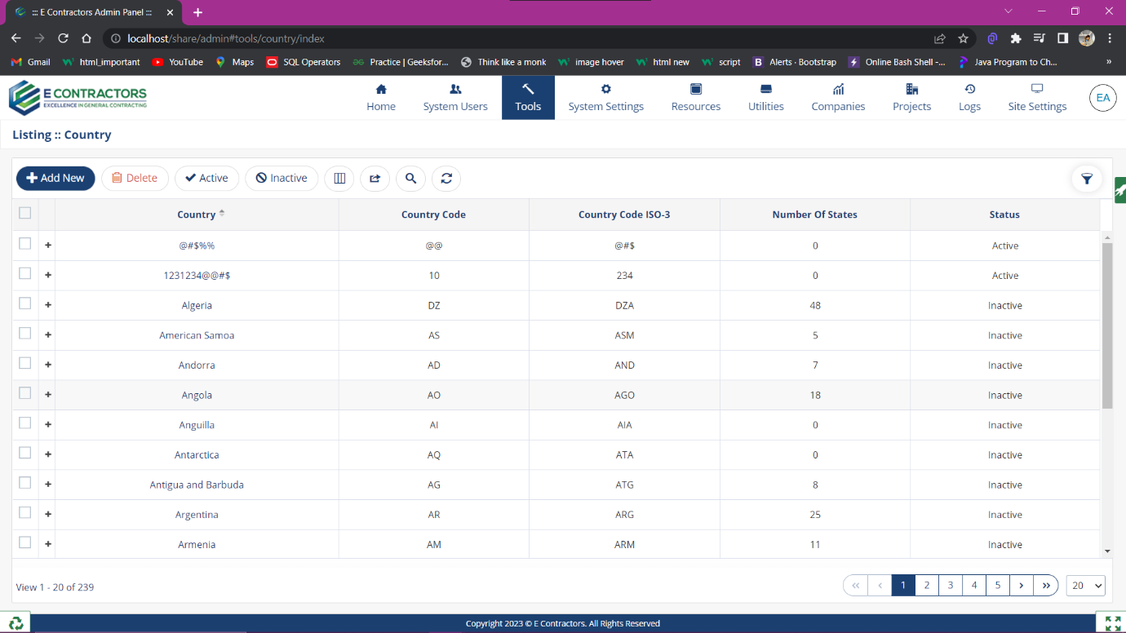

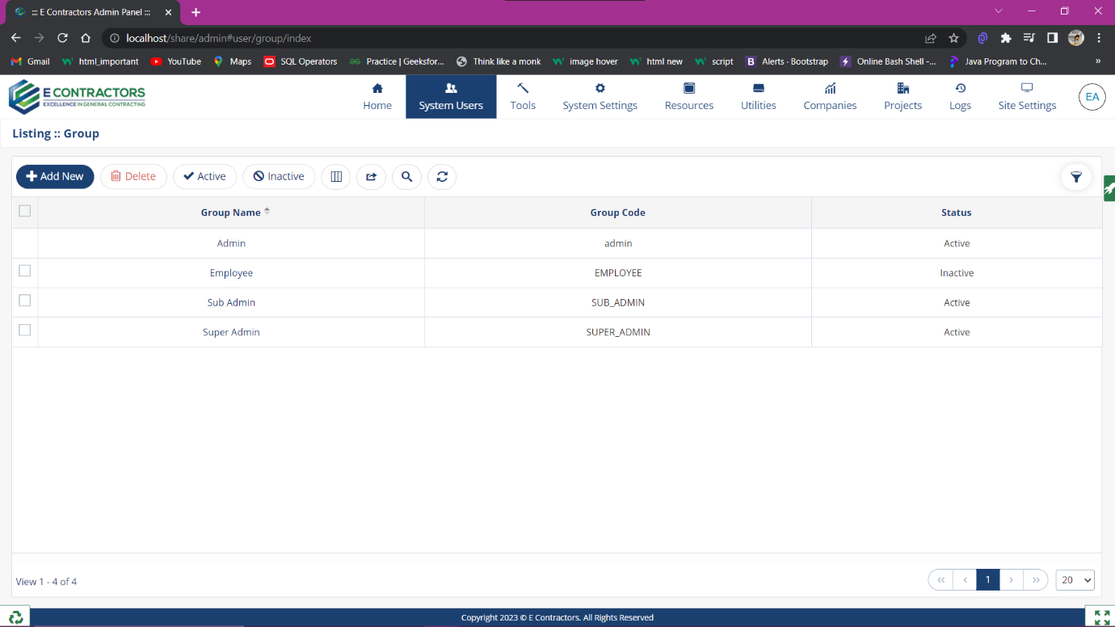

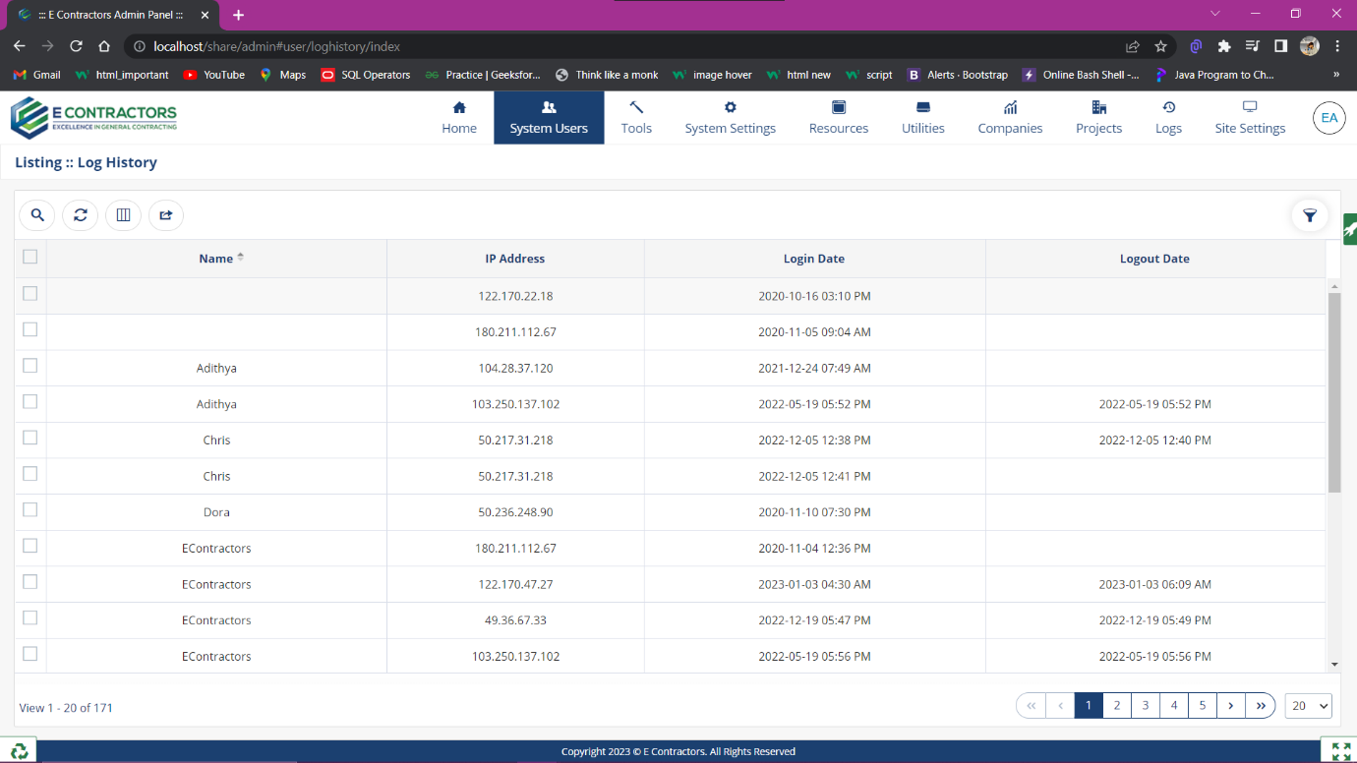

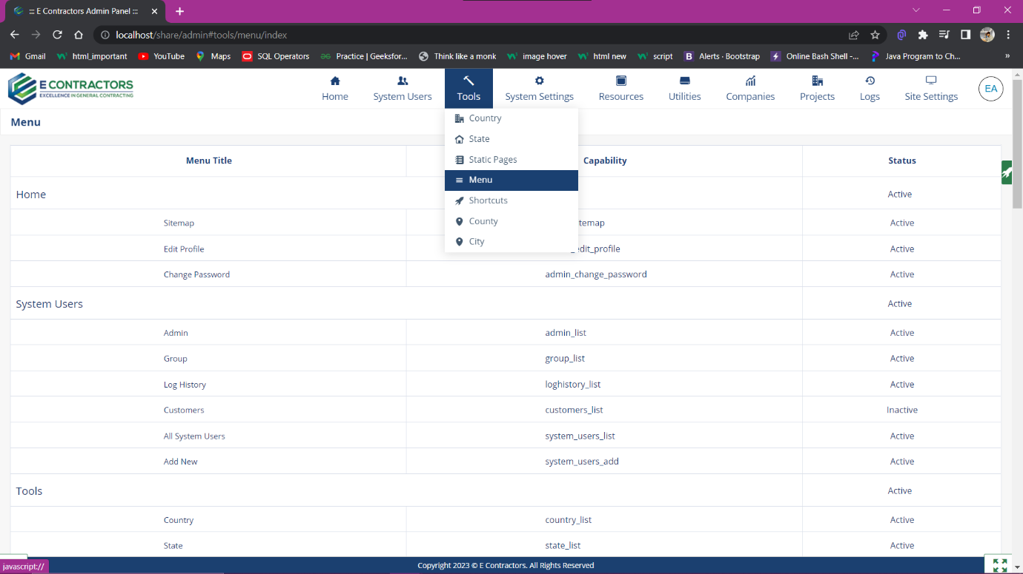

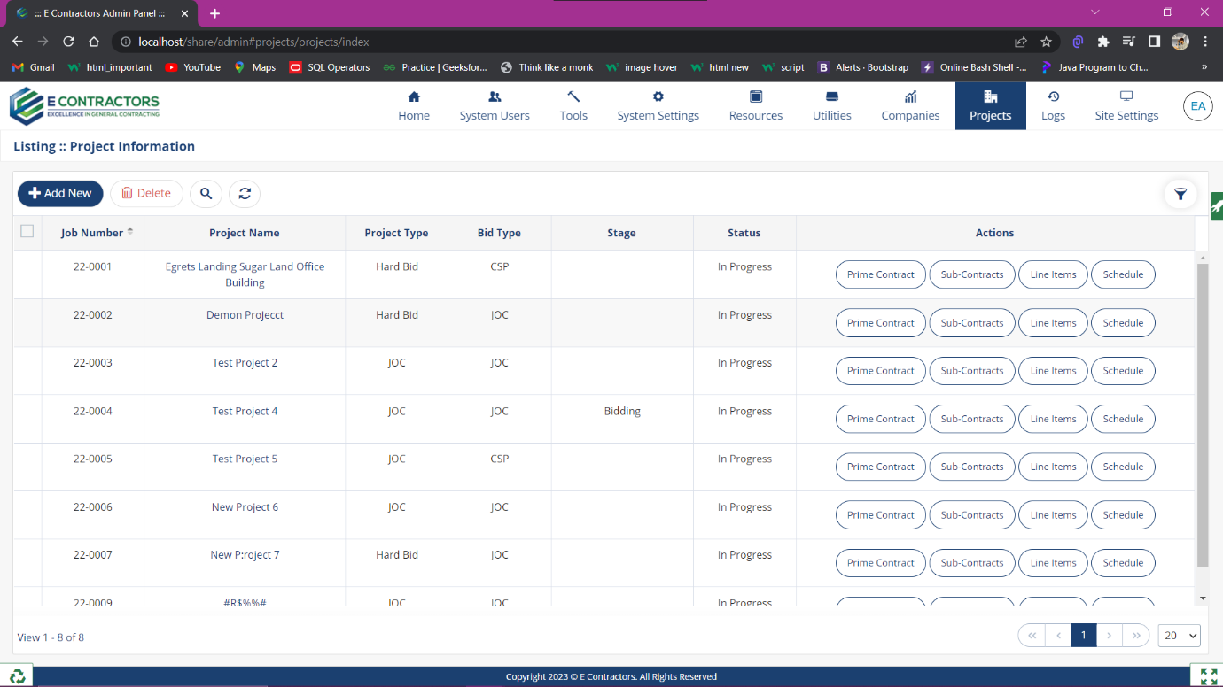

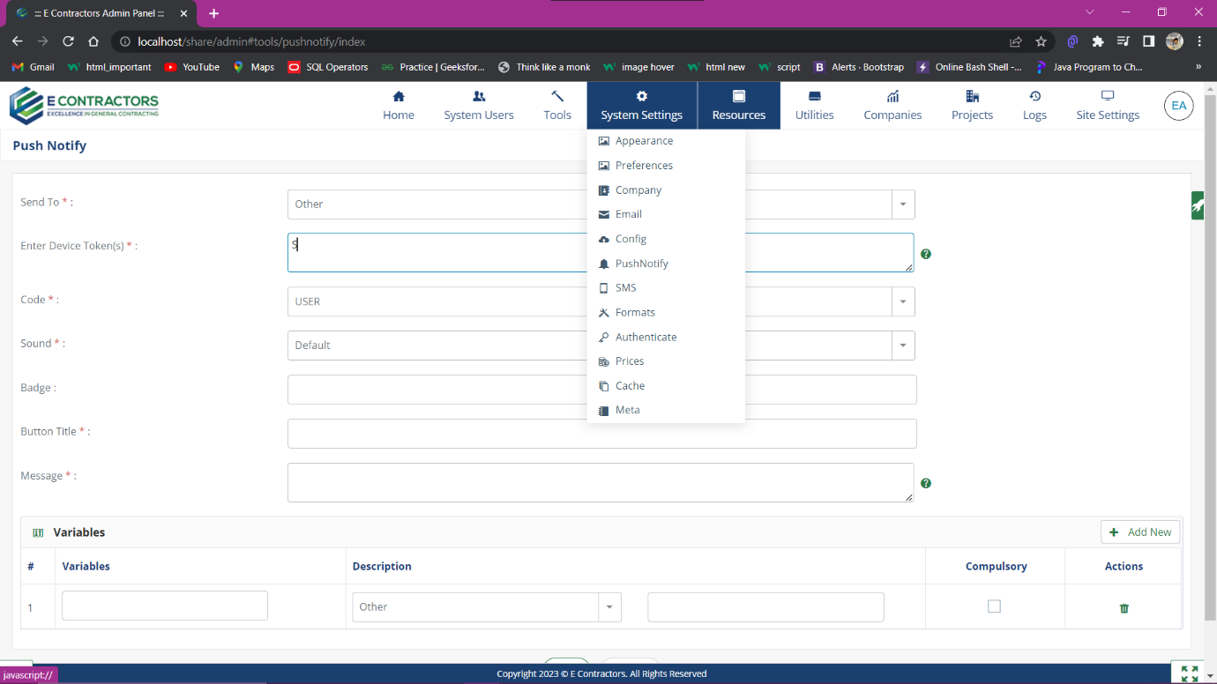

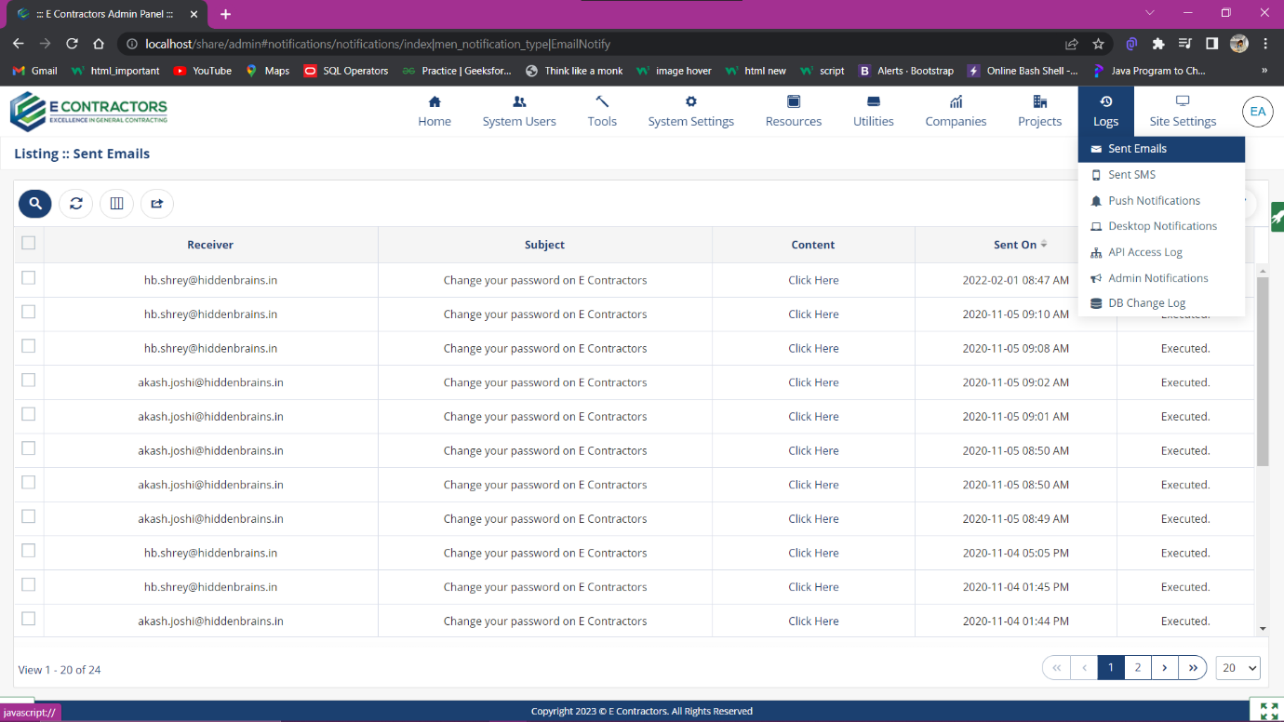

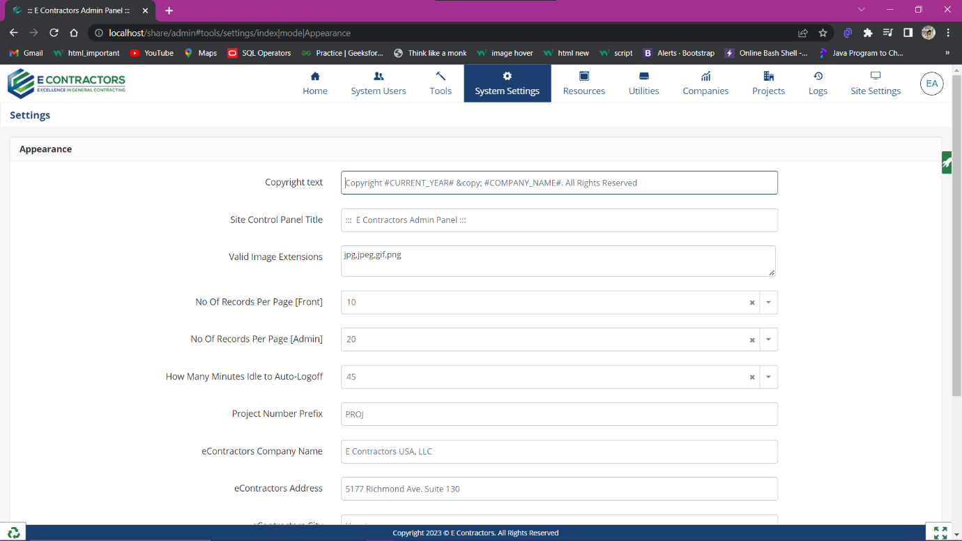

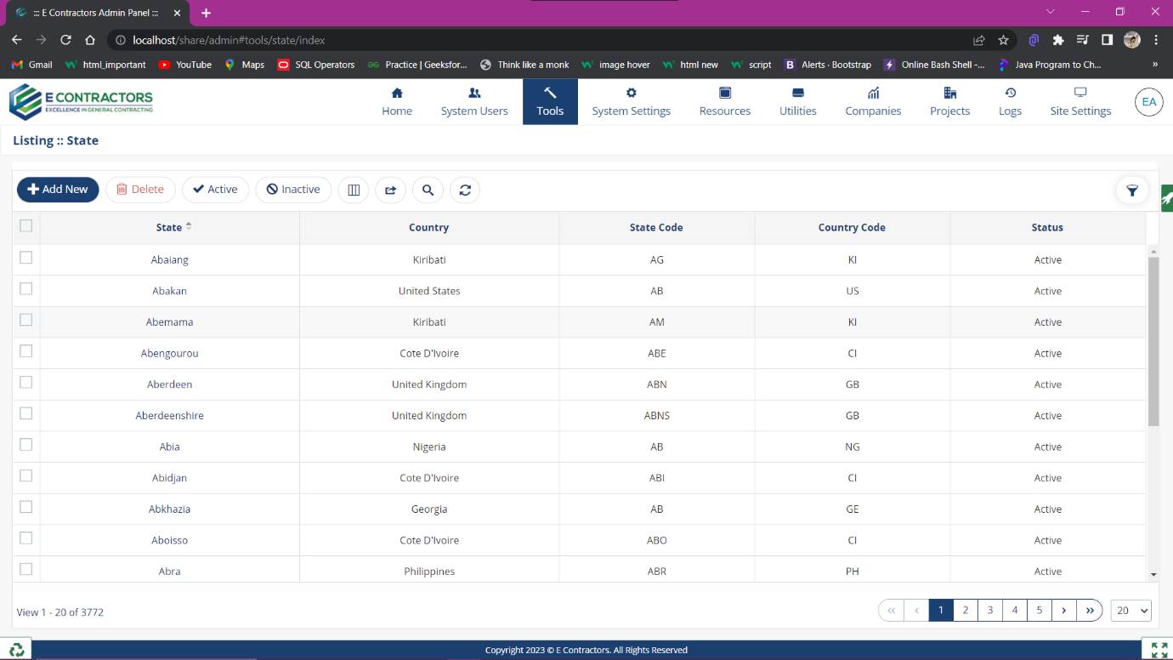

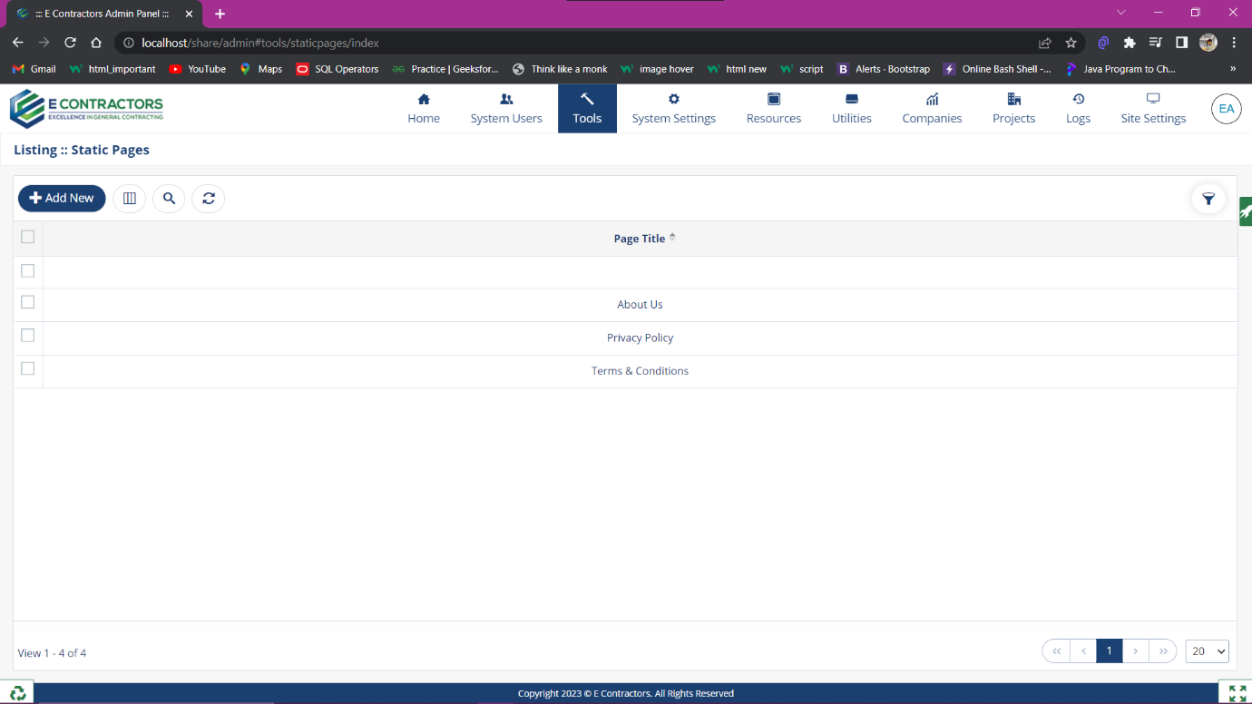

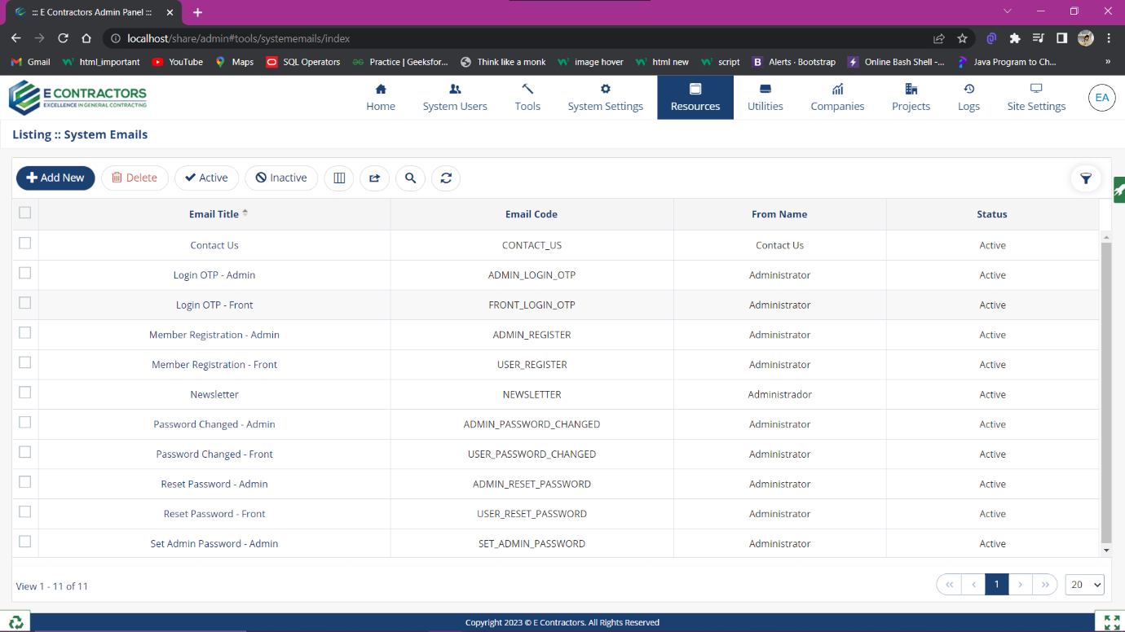



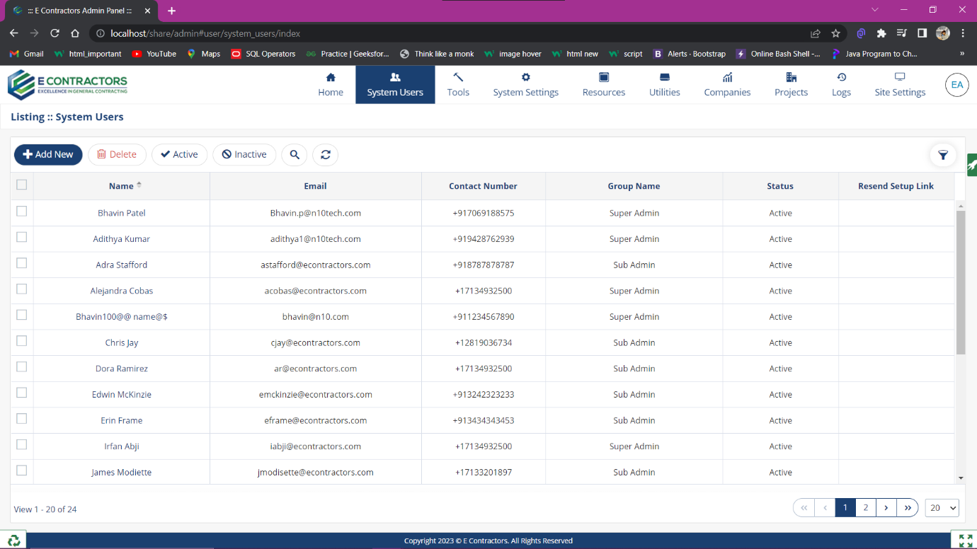

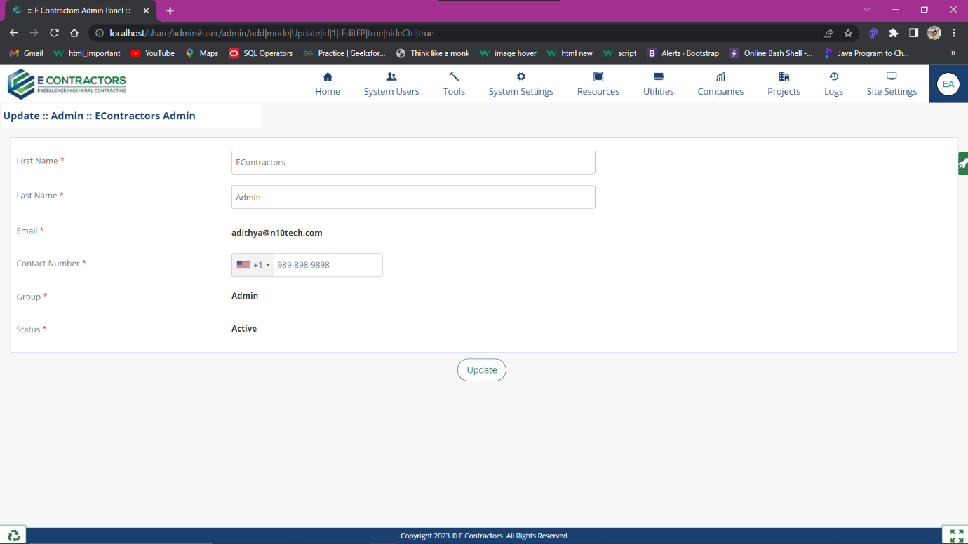

## Figma Design of N10 Website

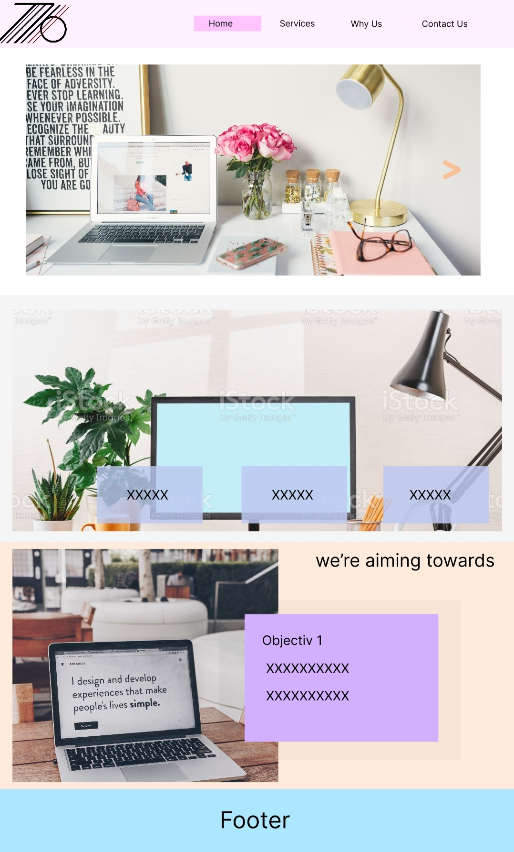

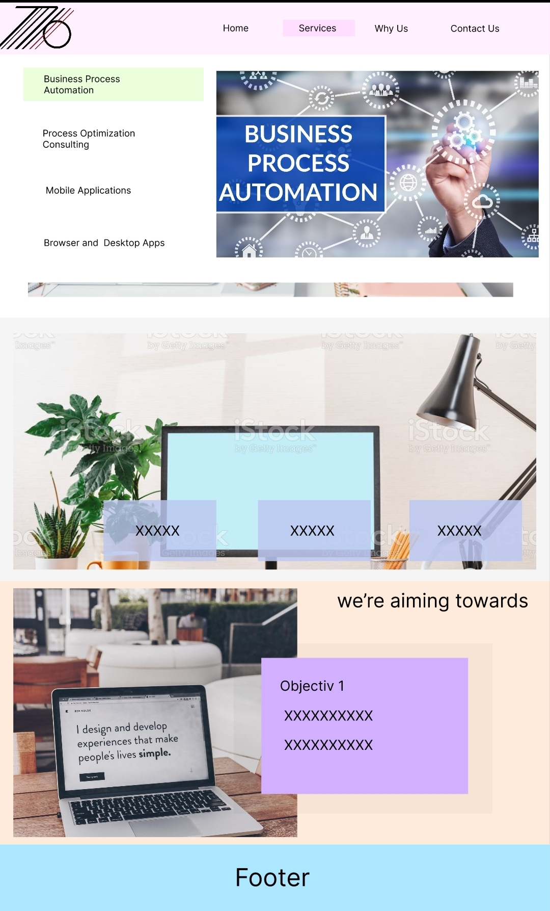

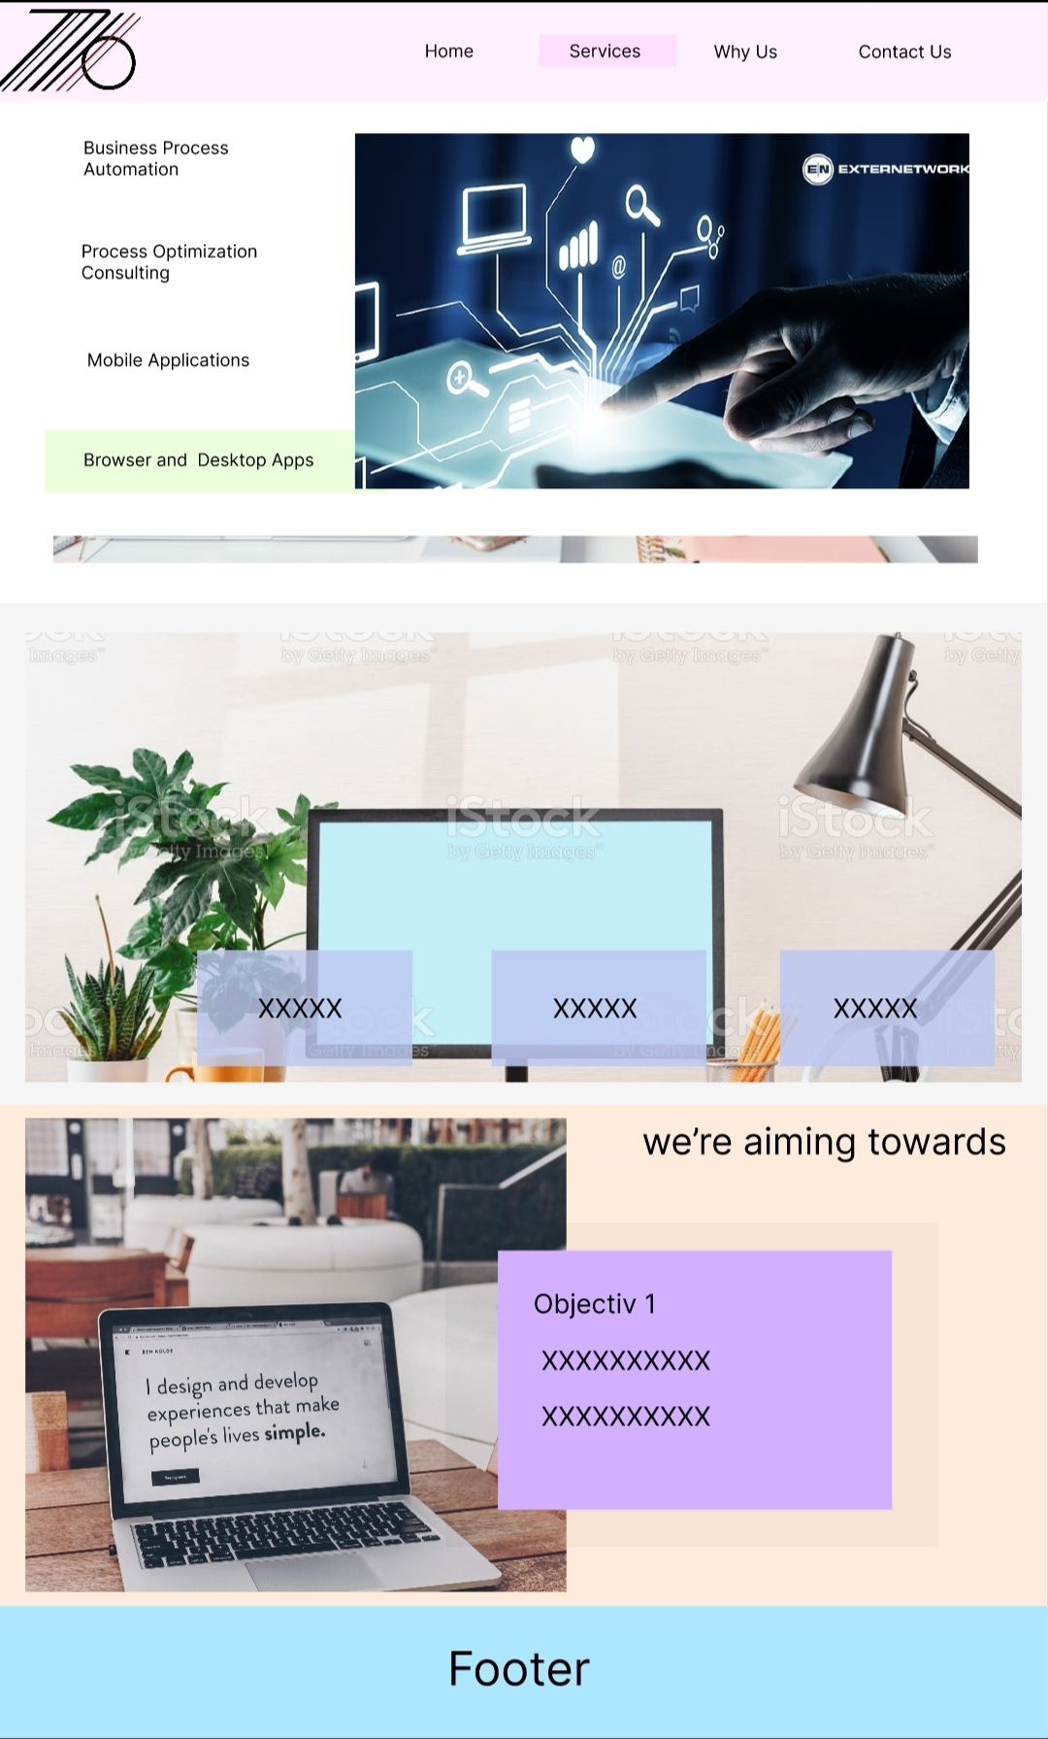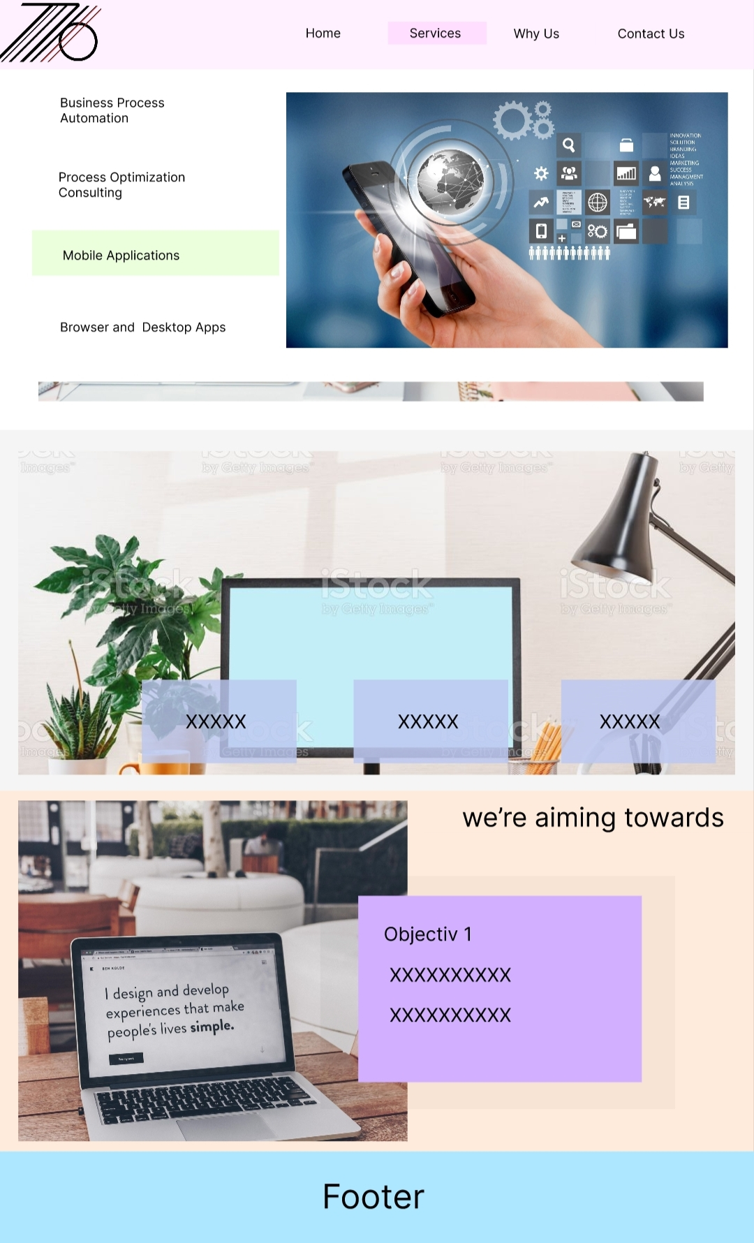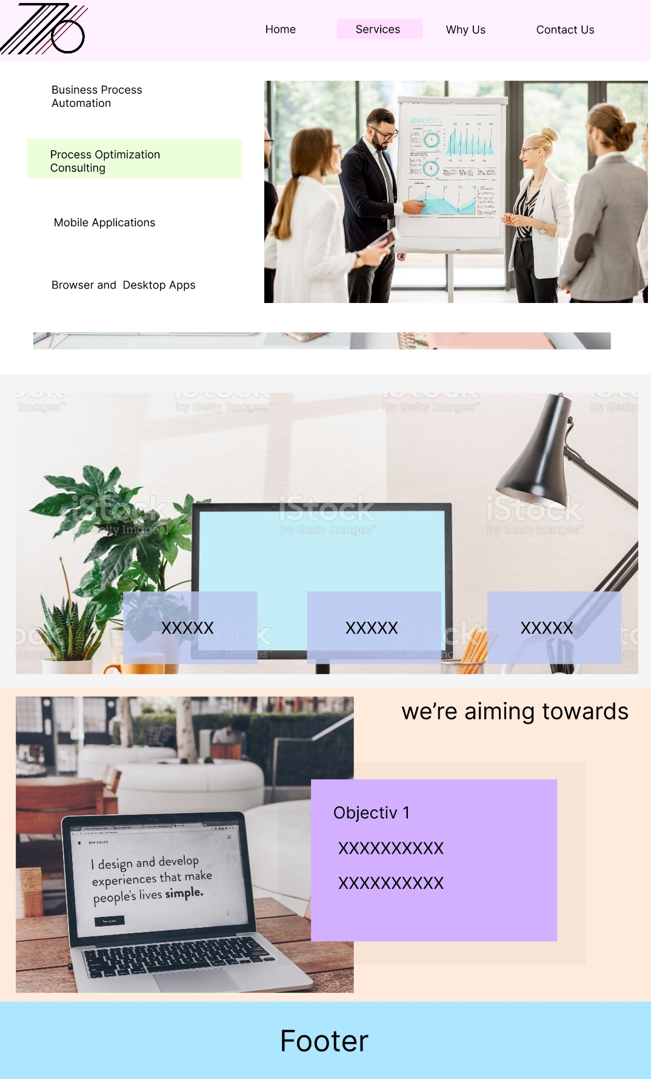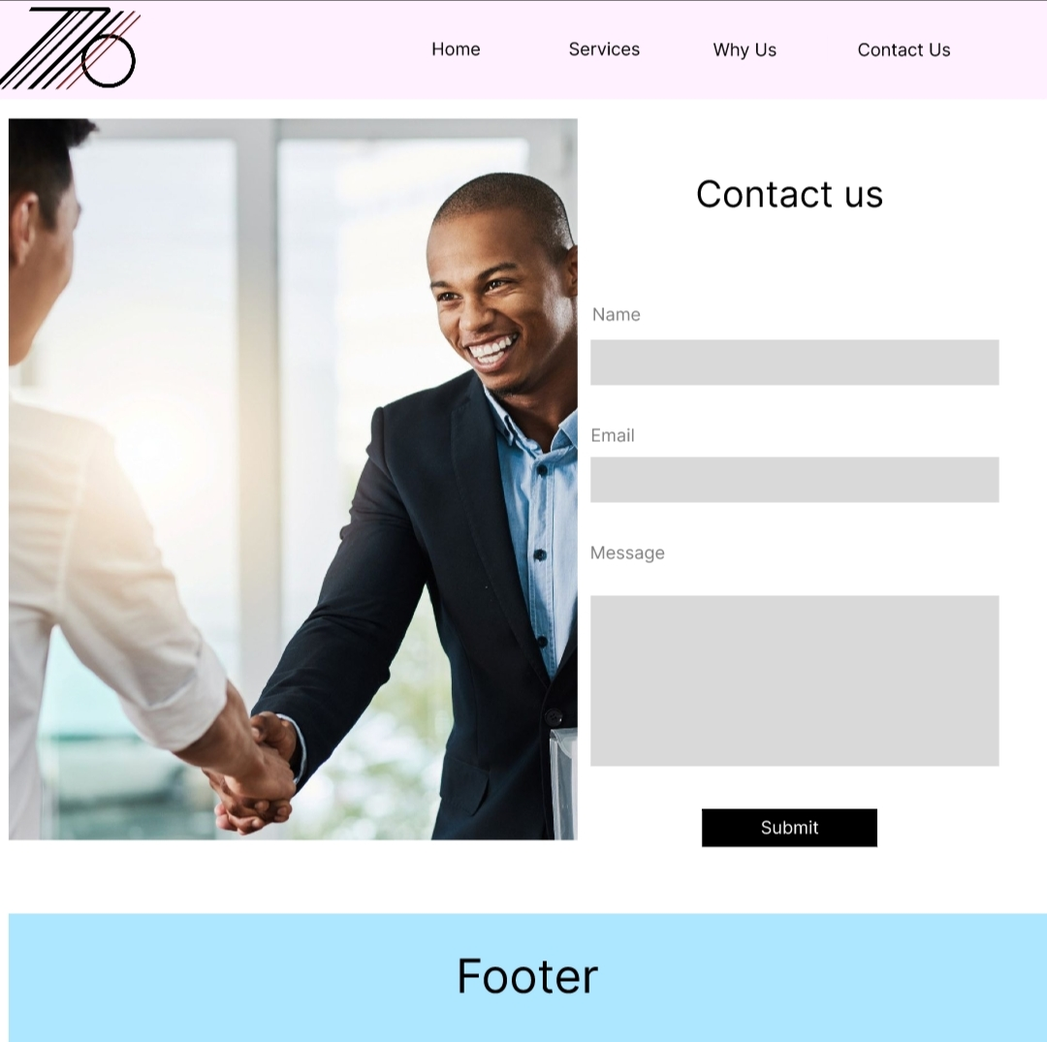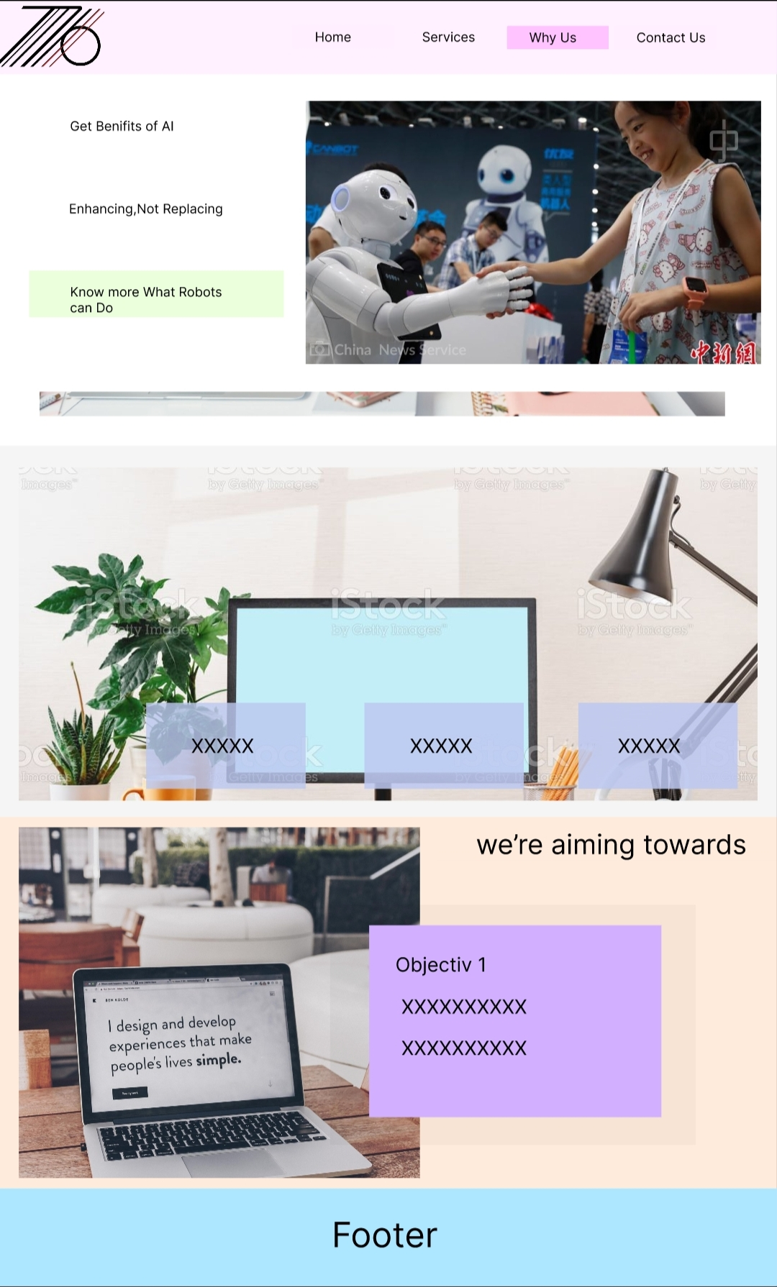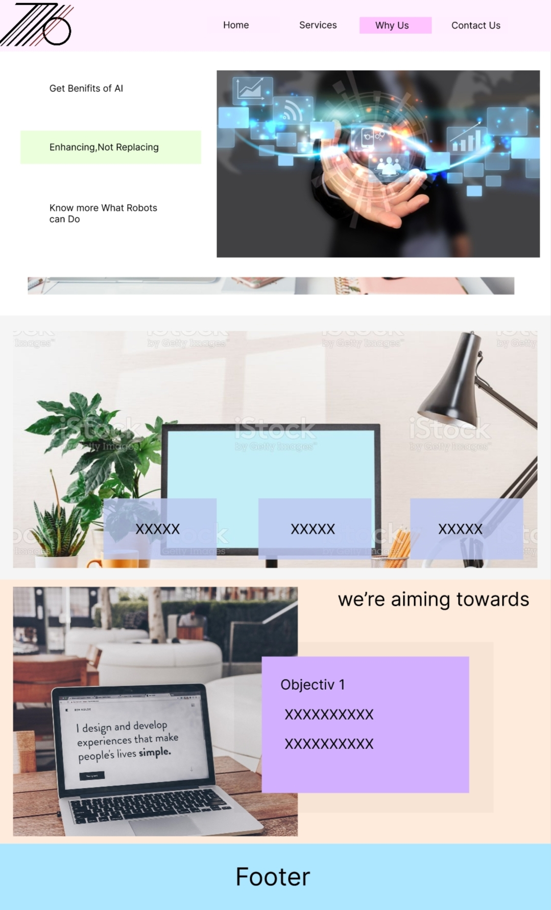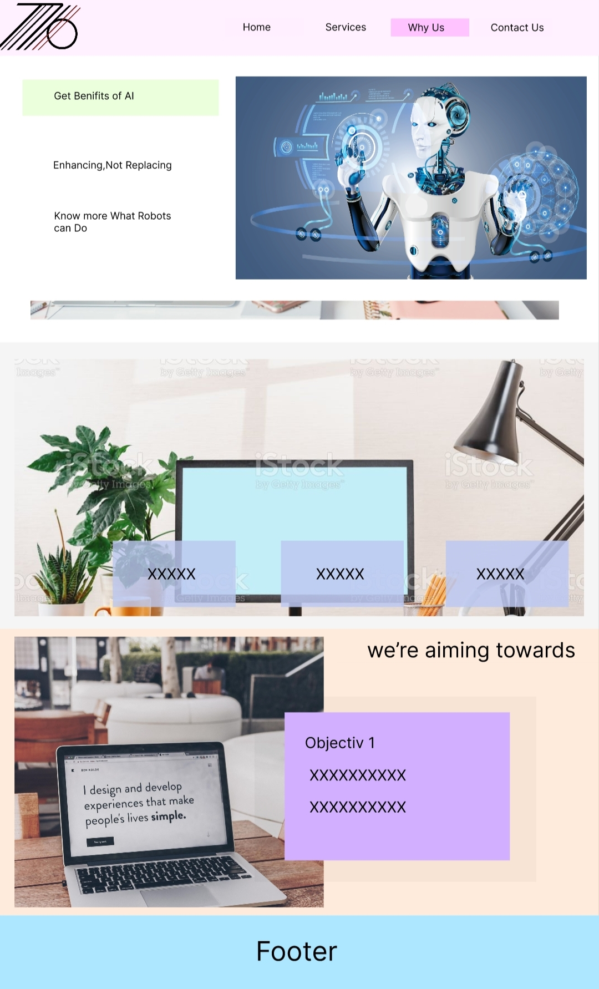

## Figma Design of Android Application

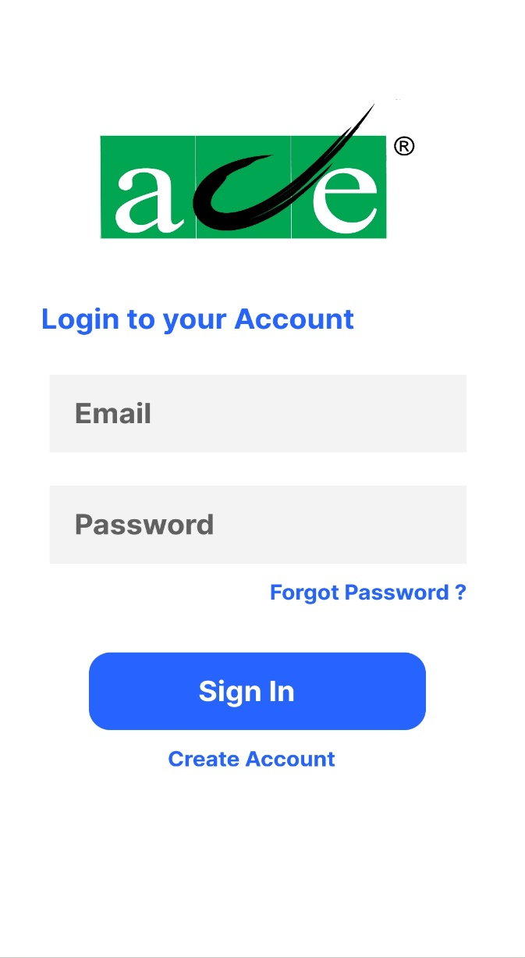

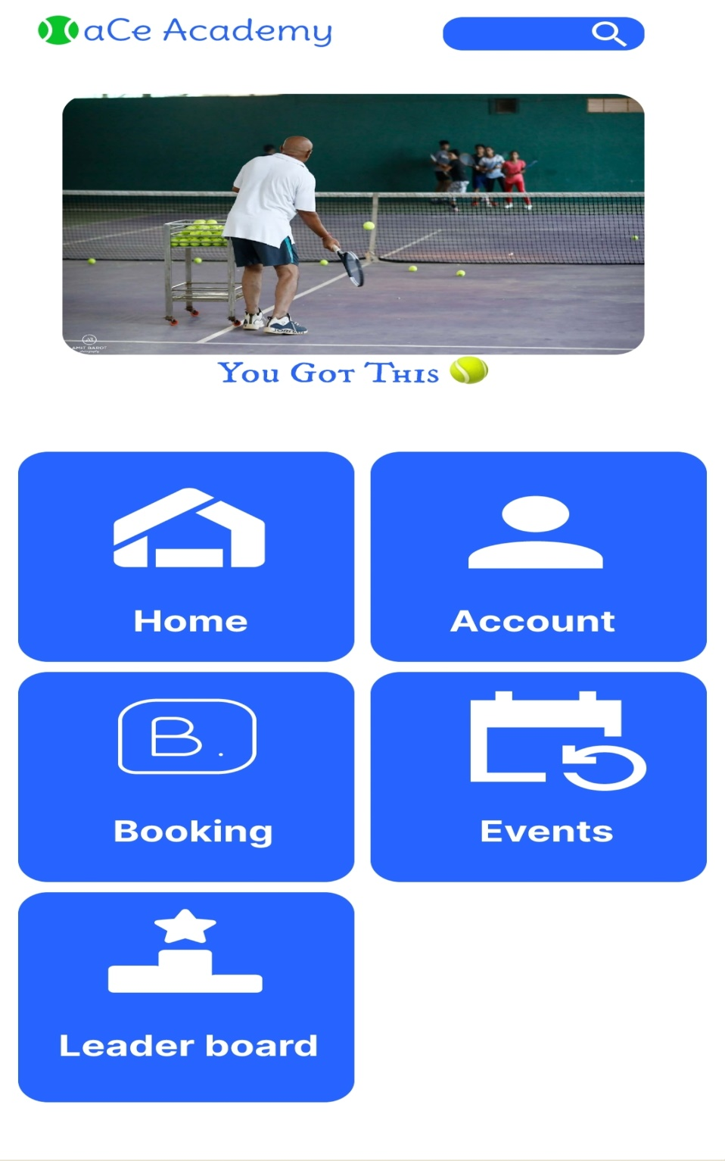

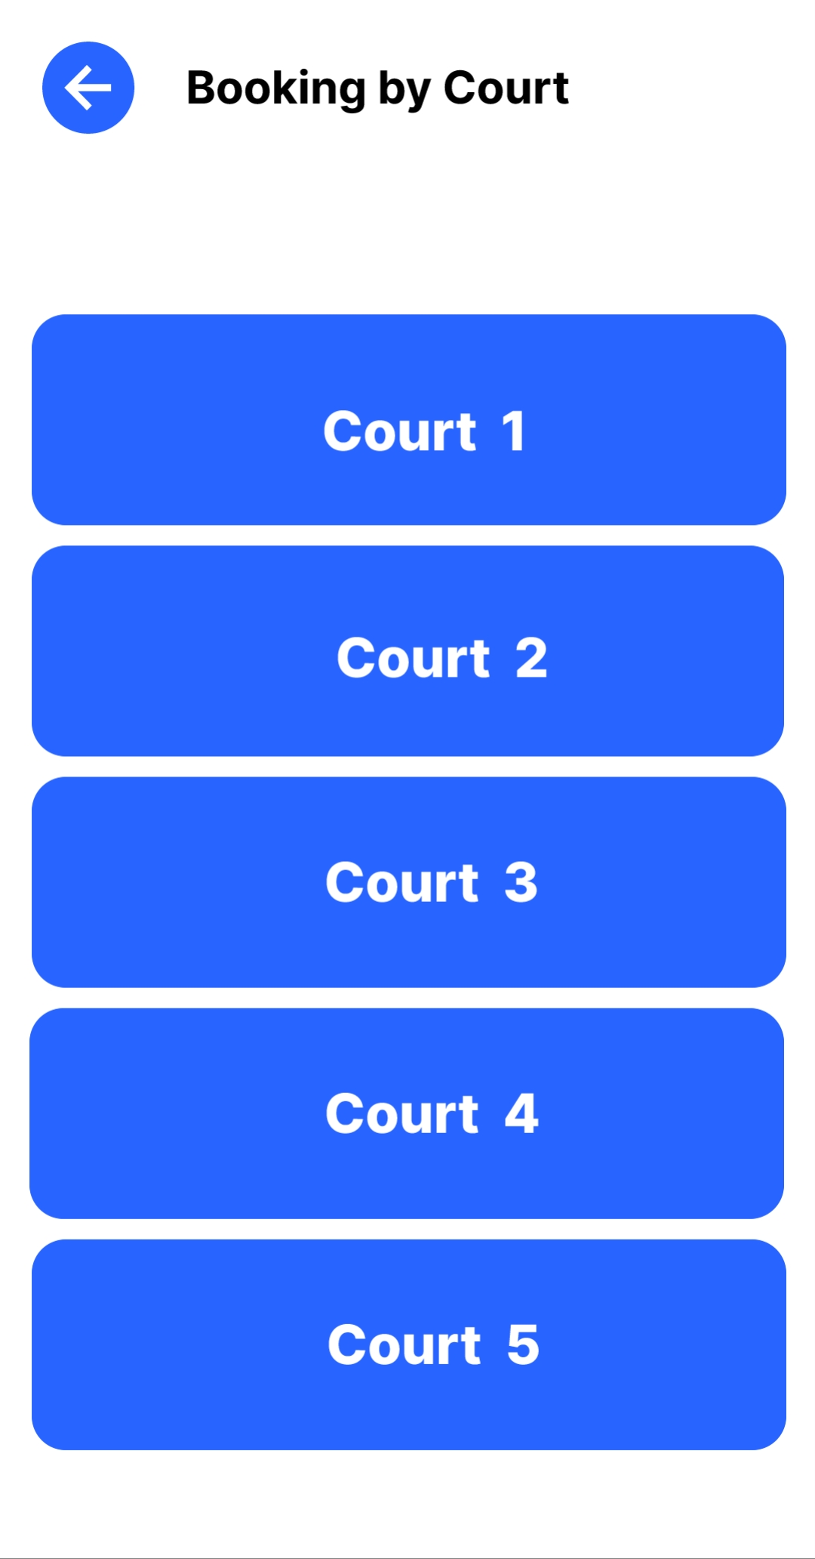

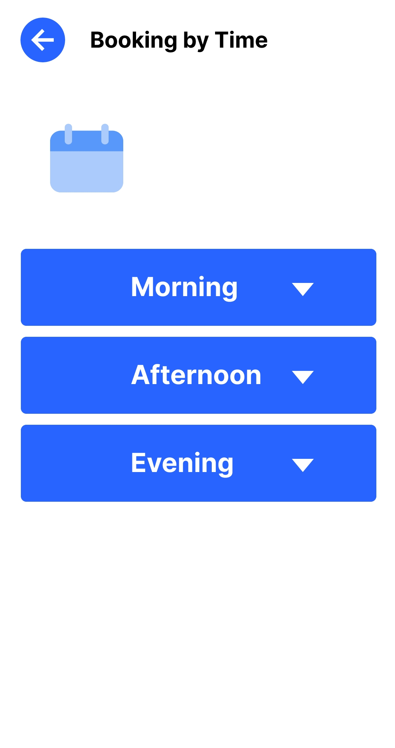

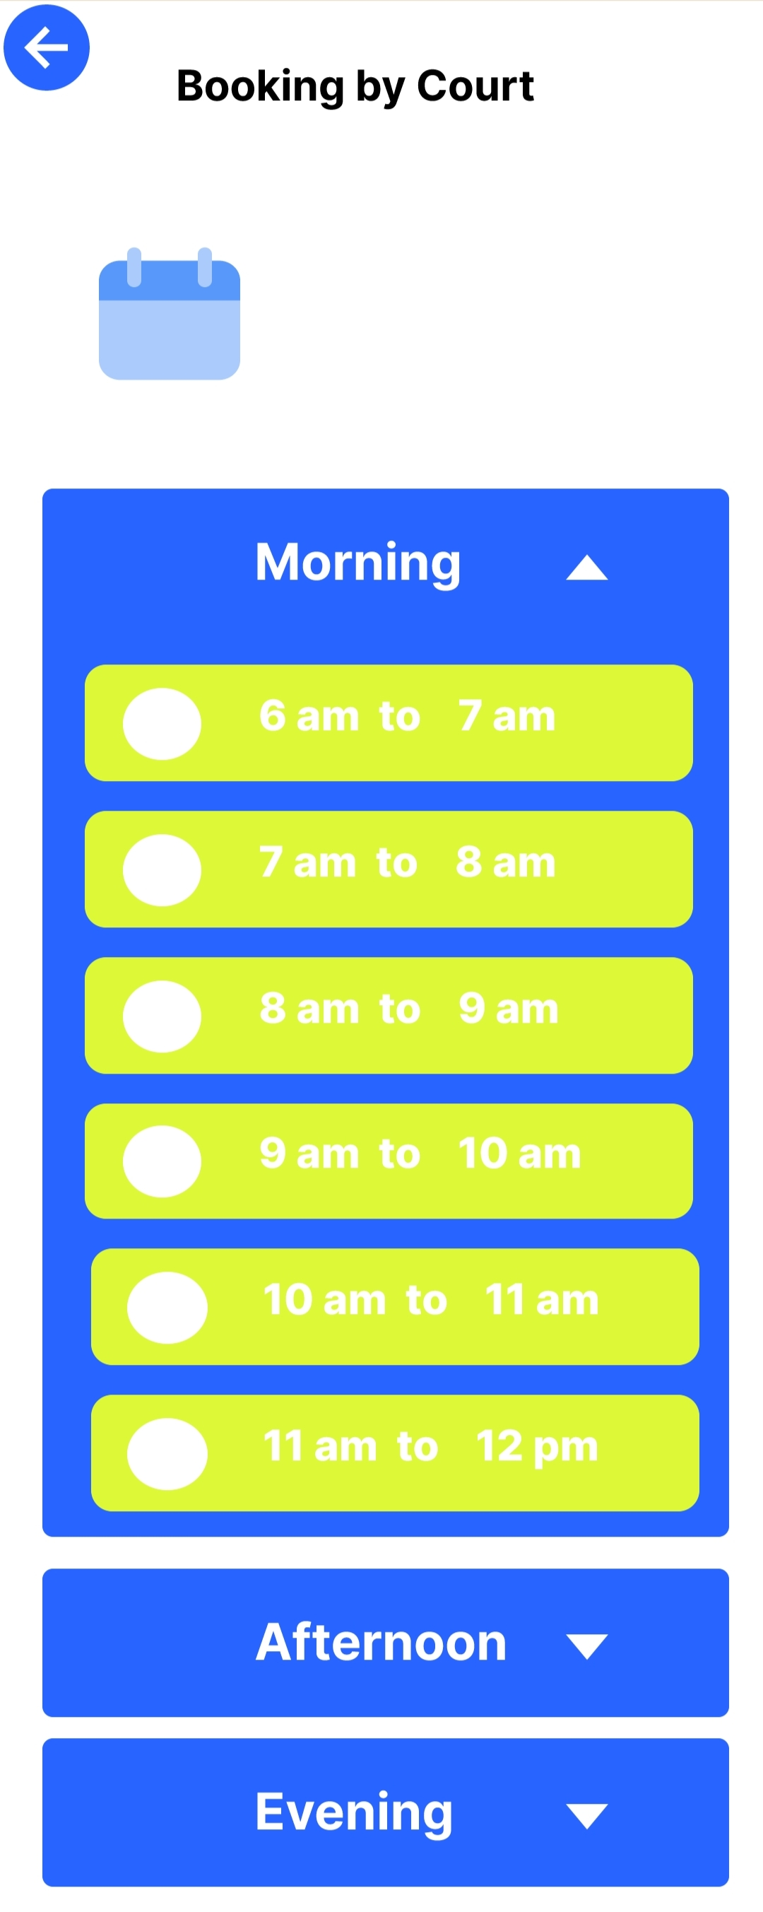

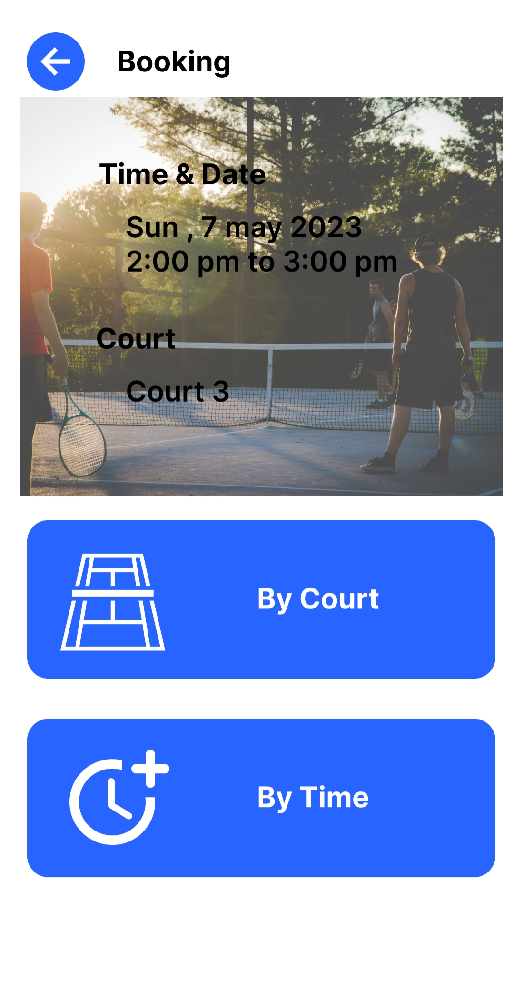



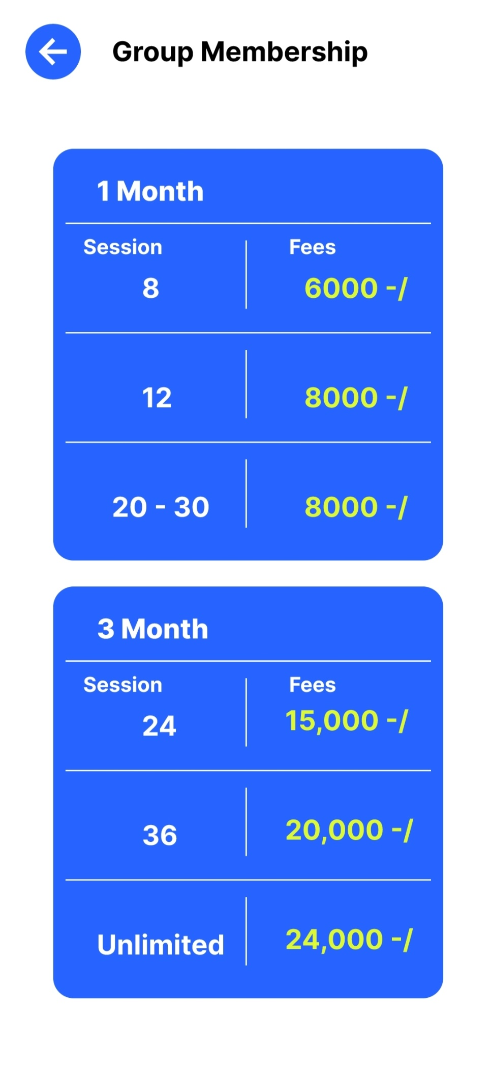

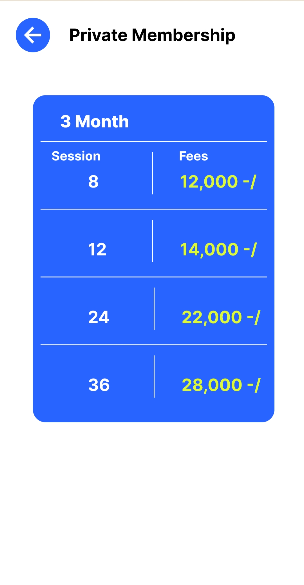





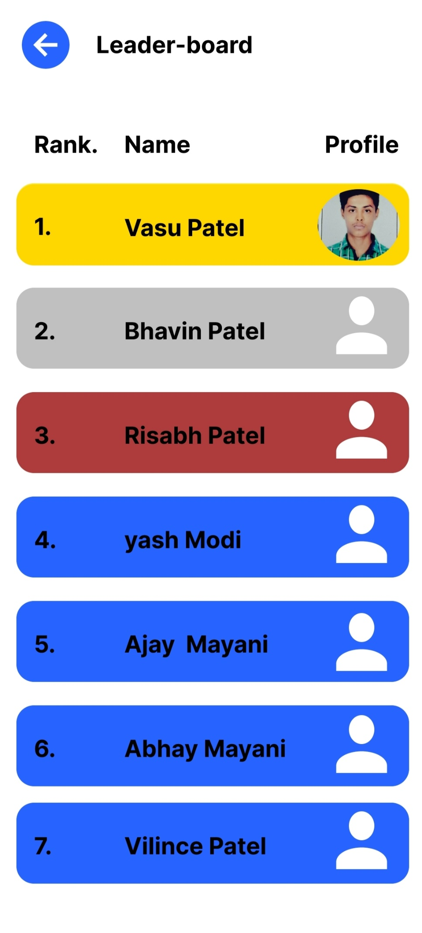

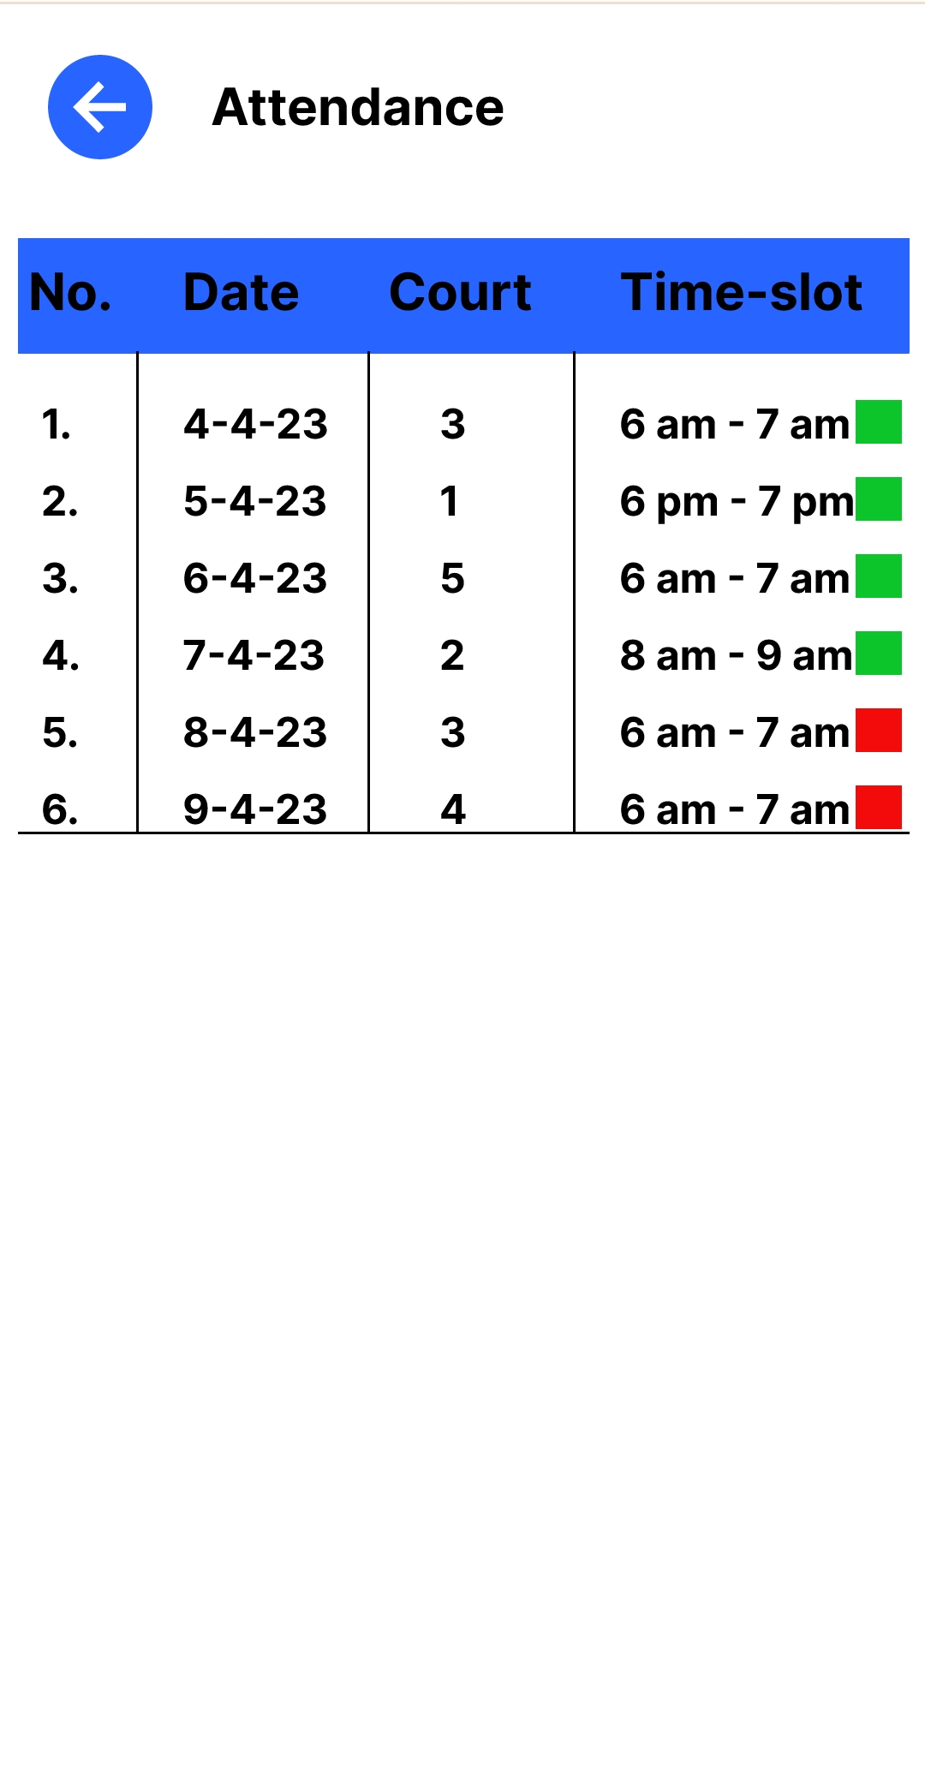

1. **Experiences of Corporate culture and Working Atmosphere**

During my time at N10 Technosoft, I had the opportunity to work on several different projects alongside other interns and experienced colleagues. The other interns were incredibly helpful, offering their expertise and support when I encountered challenges in my work. Together, we were able to collaborate and produce high-quality work that met the company's standards.

In addition to the support of my fellow interns, our manager was also a key figure in creating a positive working environment. They were very friendly and approachable, and always willing to offer guidance and support when needed. Our manager was also open to feedback and suggestions, which helped to foster a culture of transparency and communication within the team.

One of the most valuable aspects of working with such a supportive team was the opportunity to learn from my colleagues' experiences and expertise. I was able to observe their work processes and techniques, and integrate them into my own work. This helped me to develop my skills and become more confident in my abilities.

Overall, my experience at N10 Technosoft was enriched by the support of my colleagues and manager. Their willingness to help and collaborate created a positive and productive working environment, and helped me to develop valuable skills in RPA, web, and Android development.

# References

[What is Robotic Process Automation(RPA) | RPA Tutorial for beginners | RPA Overview | RPA Training - YouTube](https://www.youtube.com/watch?v=vm3AILfkE58&list=PLkkGqdBS1r08Fd6meBZ7zHJXA15Q5Up2w)

[Automation Anywhere tutorial 02 - How to Install Automation Anywhere| Community Edition | Enterprise - YouTube](https://www.youtube.com/watch?v=TQ7rEOmK4GM&list=PLkkGqdBS1r08Fd6meBZ7zHJXA15Q5Up2w&index=3)

[Automation Anywhere tutorial 03 - Create First Project | Automation Anywhere Demo | TaskBot - YouTube](https://www.youtube.com/watch?v=TzVscDac_7o&list=PLkkGqdBS1r08Fd6meBZ7zHJXA15Q5Up2w&index=4)

[Robotic Process Automation - Automation Anywhere 360 / A2019 | Udemy](https://www.udemy.com/course/robotic-process-automation-automation-anywhere-a2019/)

[Automation Anywhere 360/A2019 - Complete RPA Training Course | Udemy](https://www.udemy.com/course/complete-automation-anywhere-rpa-developer-course/)

* <https://automationanywhere.litmos.com/course/3290433>
* <https://automationanywhere.litmos.com/course/2712276>
* <https://automationanywhere.litmos.com/course/3281120>
* <https://automationanywhere.litmos.com/course/3750461>
* <https://automationanywhere.litmos.com/course/3652137>
* <https://automationanywhere.litmos.com/course/3749732>
* <https://automationanywhere.litmos.com/course/2712283>
* <https://automationanywhere.litmos.com/course/3750462>
* <https://automationanywhere.litmos.com/home/LearningPath/110459>
* <https://automationanywhere.litmos.com/course/3750649>
* <https://automationanywhere.litmos.com/course/3769763>
* <https://automationanywhere.litmos.com/course/2712278>
* <https://automationanywhere.litmos.com/home/LearningPath/117223?r=False&ts=637904317029234067>